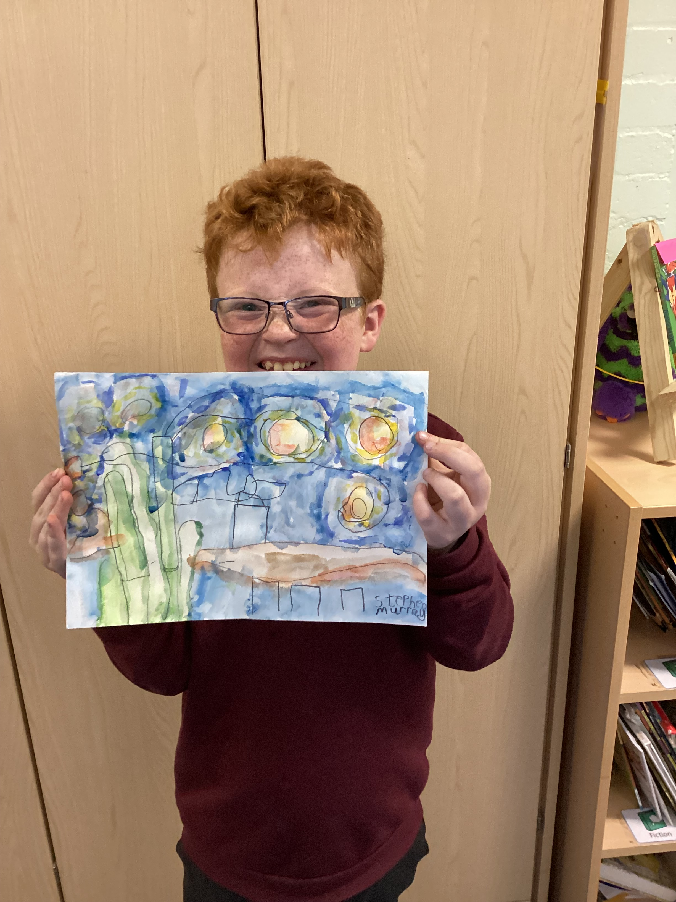
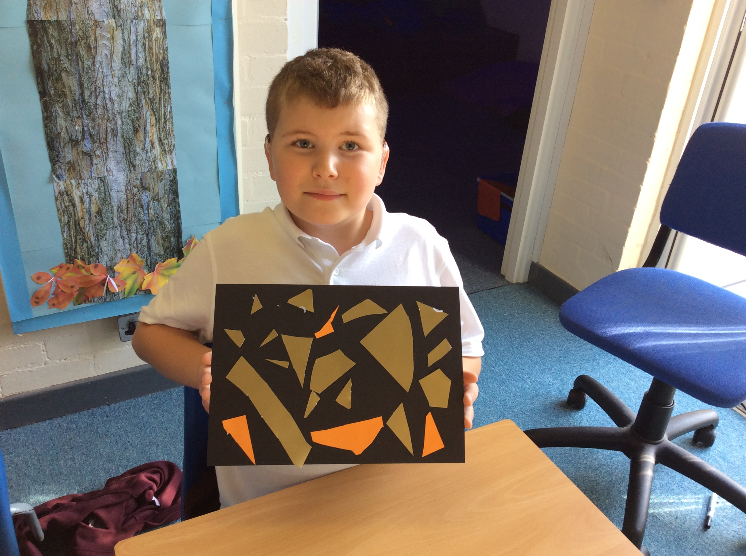
Governors Report – Summer 2023

Art Subject leader: Roz
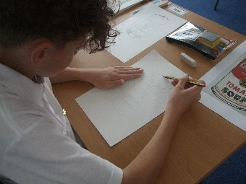
Achievements
The ‘ways forward’ identified last year from this year’s school development plan and the actions taken:
To do a staff meeting focusing on printing for staff CPD in art.
Artist Katie Lloyd delivered an Inset day for all staff on printing (identified on the staff survey as the least confident area to teach). All staff were given practical experience and support planning two art days delivering print sessions to the children. This had great impact as the staff felt more confident in delivering print and the children produced some incredible print work during this time.
To further theme the art days to support the children’s diverse art experiences.
This year we had visiting artist Katie Lloyd who concentrated on printing and upskilled the staff within this area. We will continue to train and theme art days to give diverse art experiences.
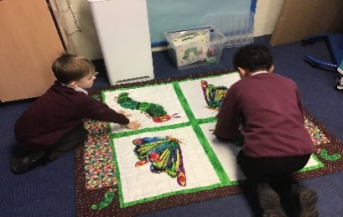
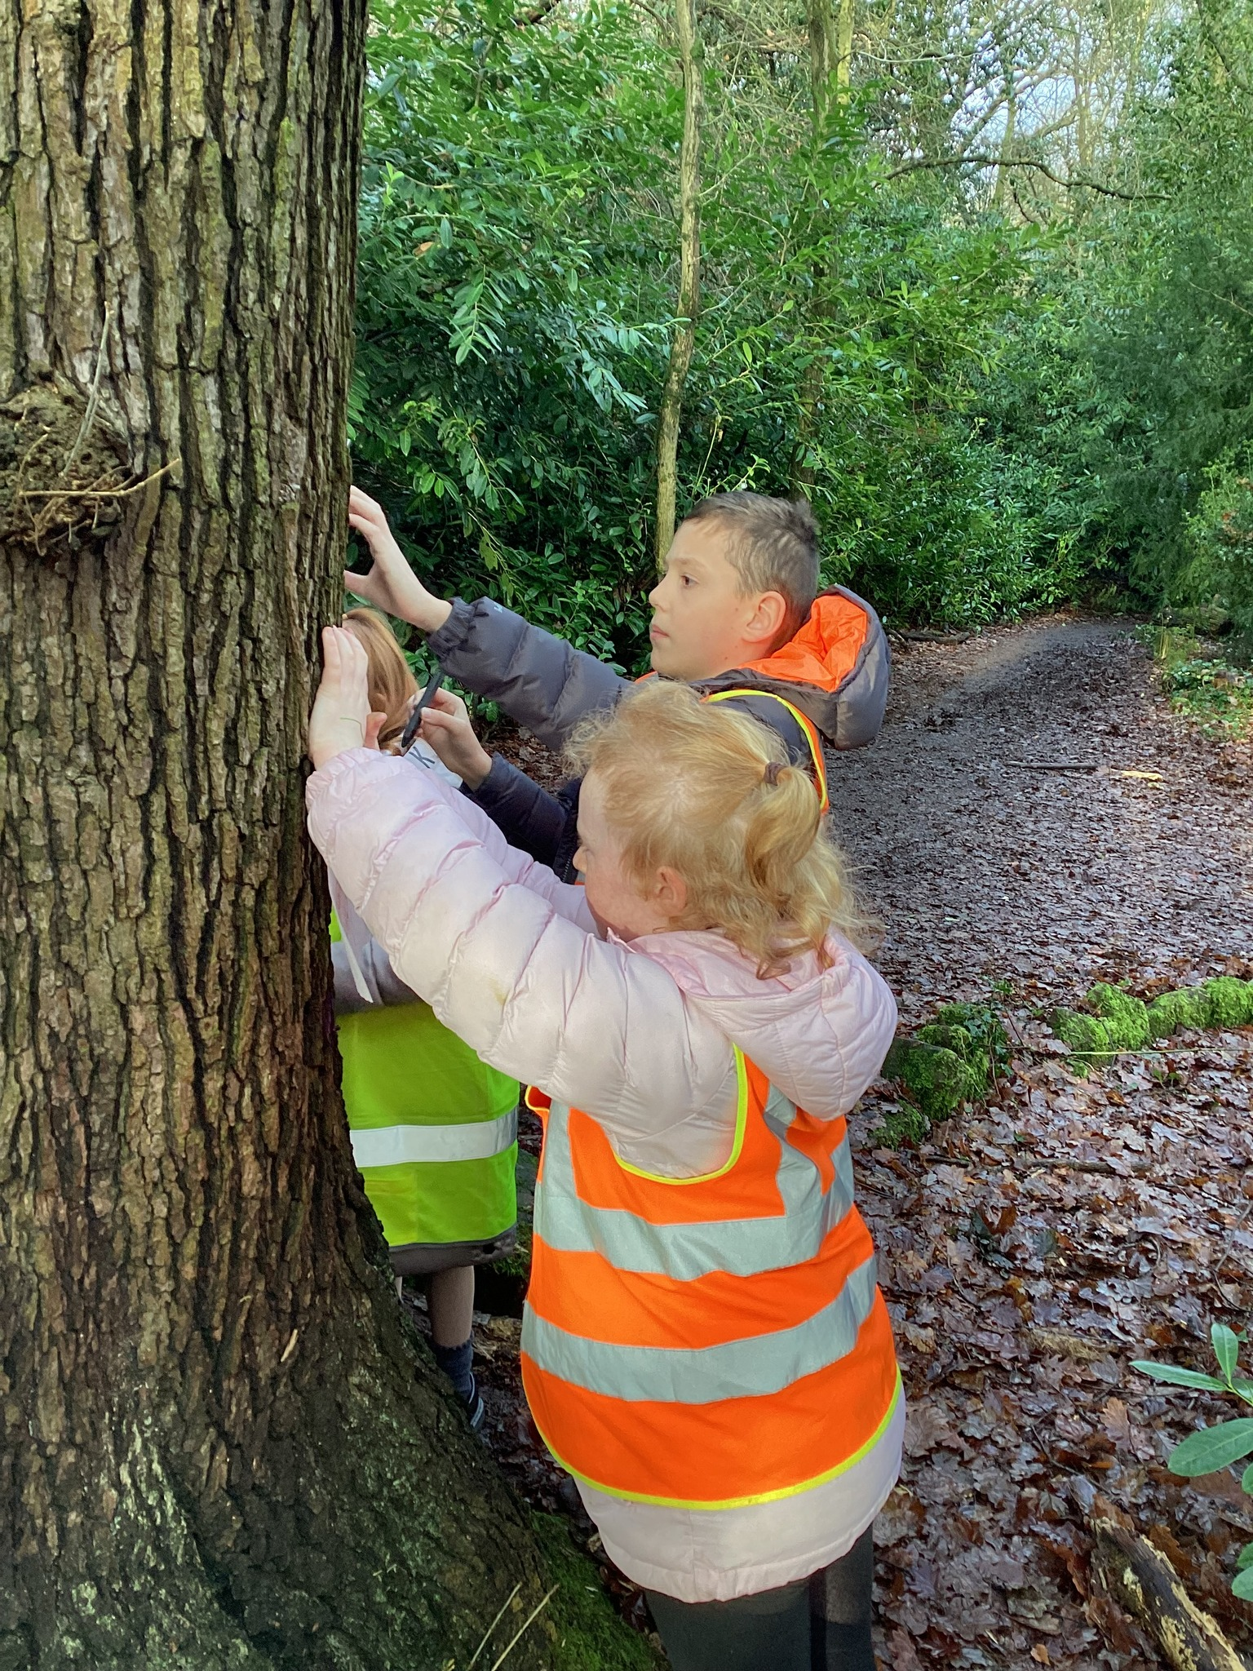
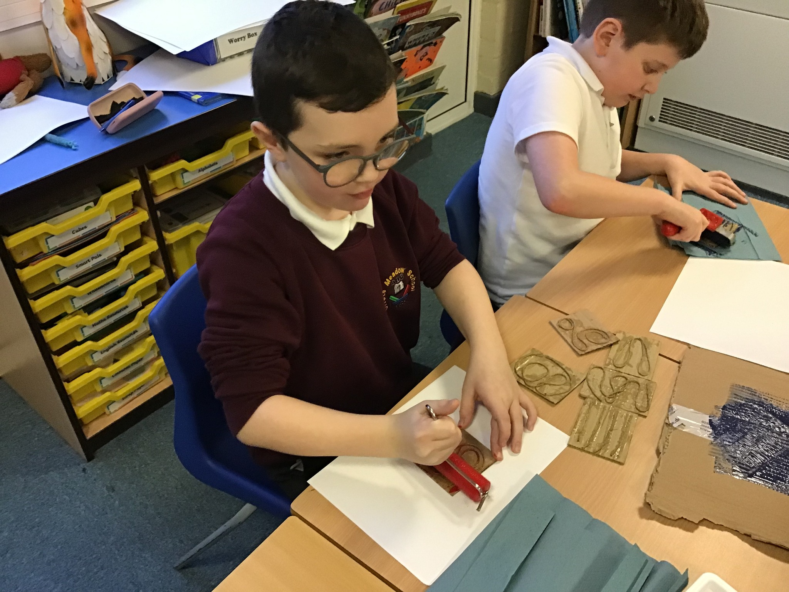
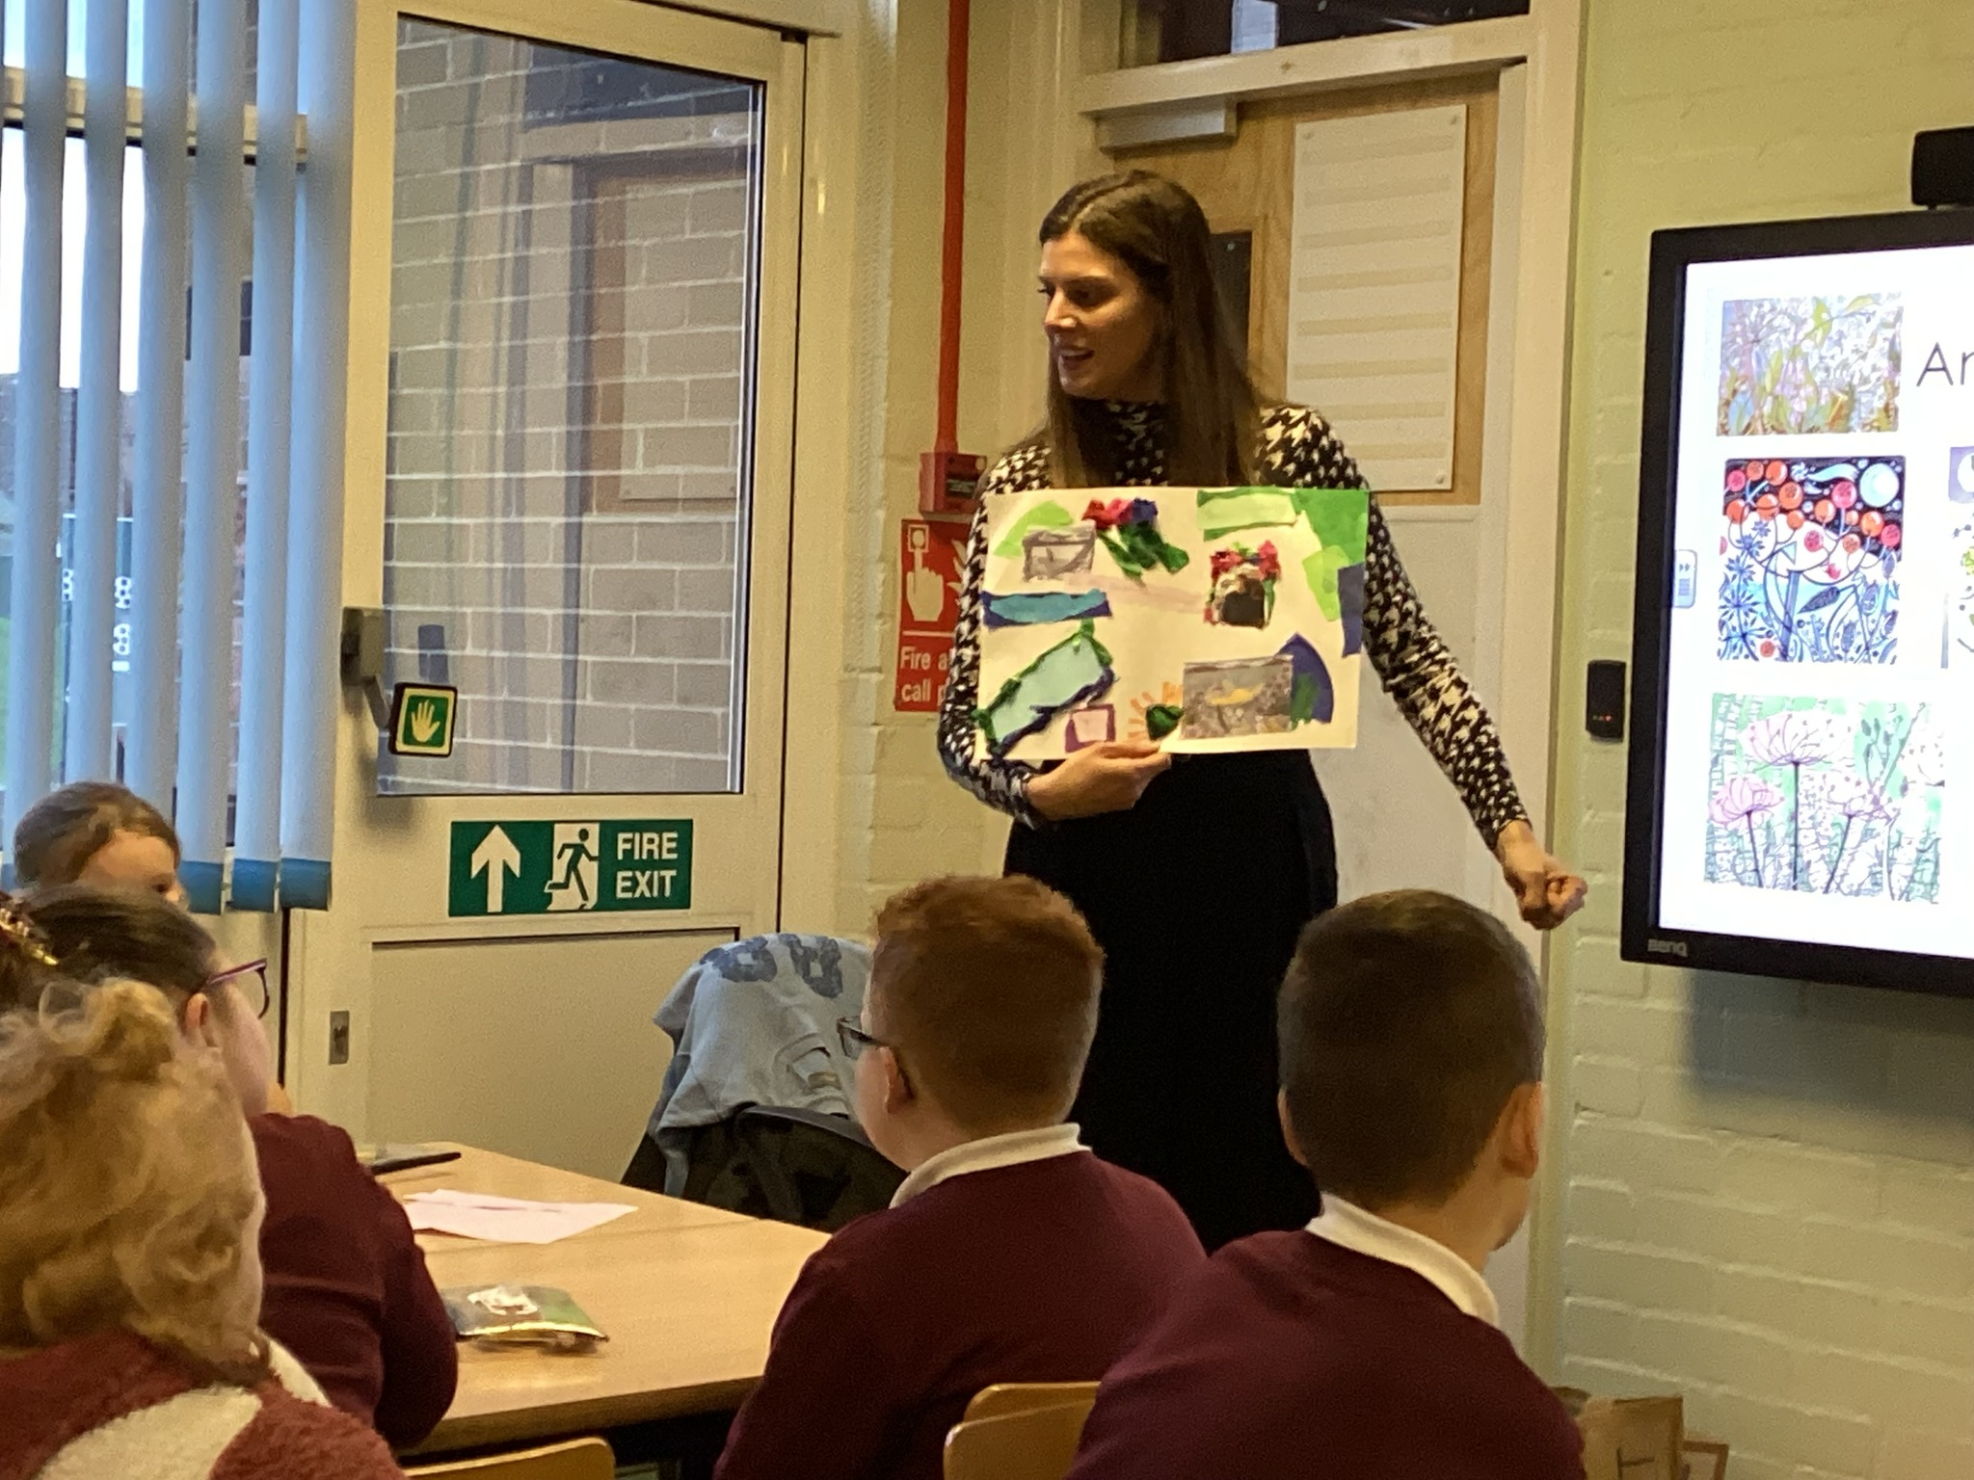
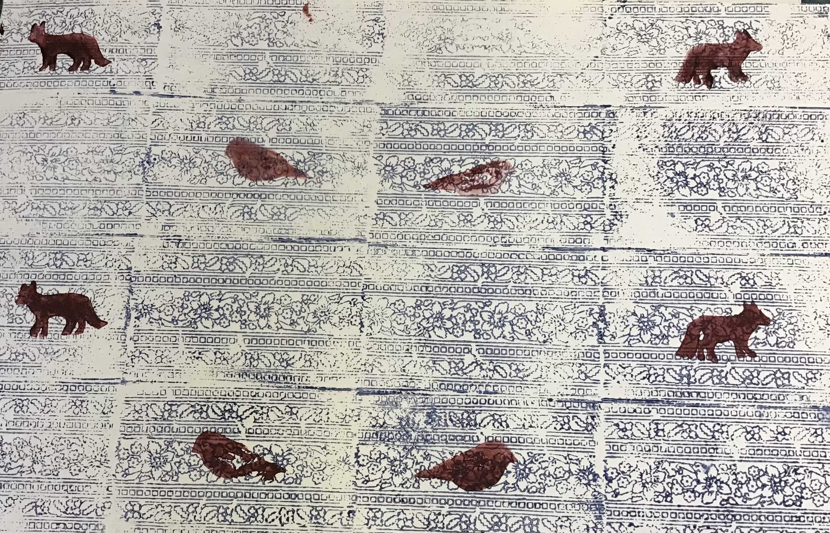

Promote enrichment activities to support culture capital – i.e. each class take a trip to Williamson Art Gallery.

6/7 classes attended art galleries this year to support culture capital. 5/7 attended the Williamson Art Gallery and took part in workshops and gallery visits and 1/6 attended the Lady Leaver Art Gallery. The Wolves our youngest class took park in sketching/mark making in the park. They will access the art gallery as they progress through the school.
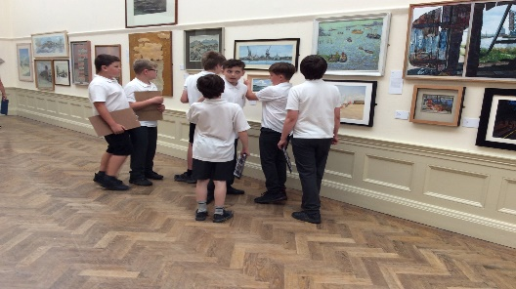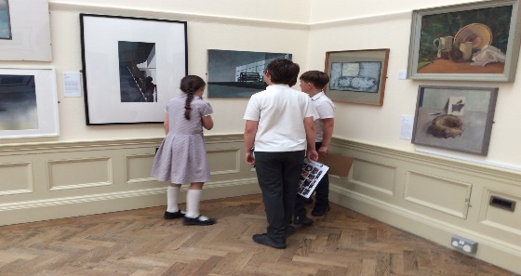
Art Days
We have completed 3 art days this year to give the children the opportunity to work on their skills and use their sketch books to develop ideas during these focused day.

Art Day 1 - raise awareness of art history – Art Day – 23rd September 2022
Our first art day focused on art history. Each class had a different artist to research (based on last year’s choice) and apply their techniques. The following artists were used:

Wolves: Kandinsky
Bears: Mondrian
Giraffes: Van Gogh
Zebras: Yayoi Kusama
Foxes: Matisse
Tigers: Henri Rousseau
Sharks: Andy Warhol
Owls: Paul Klee

During this day I completed a learning walk round the classes. You could see the children building skills throughout the day before completion of their final piece in the style of the chosen artist.

Art Day 2 and 3 - Printing – 5th and 6th June 2023
As stated above after theoretical and practical support from Katie Lloyd during the Inset supported two art days doing printing. We tried to pick a range of artists to give diversity. The artists we focused on were:

Wolves: Jo Wright
Bears: Eric Carle
Giraffe: Angie Lewins
Zebras: Mark Heald
Tigers: Mark Chagale
Foxes: William Morris
Sharks: Tatiana Arocha
Owls: Sophie Munns

The art days directly after the Inset supported the teachers in delivering new ideas and techniques it also was resourced well for the whole school to participate. The work completed by the children (evidenced in sketch books) was fantastic and demonstrated progression in skills over the two days.

Monitor children’s progress and look for patterns in performance

Class | Class Average | FSM | Non FSM | Girls | Boys
Wolves | 0.7 | 0.7 | 0.6 | 0.5 | 0.7
Bears | 0.7 | 0.7 | 0.7 | 0.8 | 0.7
Giraffes | 1.4 | 1.4 | 1.4 | 1.5 | 1.4
Zebras | 1.8 | 1.8 | 1.8 | - | All boys
Foxes | 2.6 | 3.1 | 1.8 | 2.0 | 2.0
Tigers | 1.7 | 1.5 | 2.2 | 1.5 | 1.8
Sharks | 3.1 | 3.3 | 3.1 | 3.8 | 3.0
Owls | 2.9 | 3.0 | 2.7 | 2.6 | 3.1

On analysing the art data it is noted that the gap between the girls and boys is not significant enough to cause concern. There is only one of the classes that FSM did not do as well as the non FSM children (Tigers). This is something that will be monitored. Next year we will continue to promote cultural capital in art through giving children real life cultural experiences i.e. visiting art galleries to support narrowing the gap further.

CPD
This year I have undertaken termly online training in art through the School Improvement Liverpool Art and Design Subject Leader Briefing. The briefings have been really informative and given lots of ideas and current information on the teaching and learning of art. Katie Lloyd trained myself alongside the staff she delivered a practical based session to model good practise. After this I have used staff meetings to feedback on book scrutiny and learning walks.

Quality of teaching learning
Monitor children’s progress and look for patterns in performance
See analysis of Art data above.

Art Book Scutiny
Art work continues to be split into two books. The dimensions art work is in the topic books and art files and the art sketch books demonstrate the work from the art skill developing days. Art book scrutinises have taken place each term to moderate coverage and skill development. On monitoring the art books the coverage of art is good and the art books show clear progression of skills.

Learning Walk
My learning walks were an extremely positive experience. They took place during the art days. The children were engaged, involved, enthusiastic and benefiting from the activities being taught. They were answer simple questions about their learning and lessons showed a clear model of previous learning, new learning and what is happening next. All children appeared to love the art days and were creating some lovely pieces of art.

Pupil Voice
Out of the children that were surveyed (Class based survey):
90% found art lessons enjoyable.
100% could name some skills they had developed in art.
100% could name a famous artist.
Now only 12% (Wolves Class) of children haven’t visited an art gallery in comparison to 28% last year–we will continue to promote cultural capital (our youngest class Wolves will have the opportunity to visit during the next academic year).

Staff Voice
100% of staff commented positively about teaching art.
‘Enjoyable time for children to be creative.’
‘Children enjoy throughout’
‘Children are all engaged and have shown clear progression across the year.’
‘The children love art. Art is accessible to all. We have a large range of activities for all.’
100% of staff enjoyed teaching the art days and found it useful having time to compete a longer art project.
‘Art days are a real treat; they allow children to build skills over a day and create a piece of art’
‘Yes the days five you more time to complete step by steo projects.’
‘Having a full day/2 days to complete projects; RW giving time and guidance and resources before we began.’
100% of staff said they found the school curriculum documentation for art and design helpful.
Drawing was flagged up as requiring more CPD.

Strengths
What were the strengths in your subject you found this year from all your moderation activities?
- The Inset held by Katie Lloyd on printing.
- The discrete art days show clear progression of art skills in the identified areas.
- The quality of work.
- The variety and diversity of famous artists looked at.
- The enthusiasm of staff.

- Ways forward
- To subscribe to Kopow to support step by step tutorials (from Teacher survey)
- To book an artist (drawing) to support cultural capital and support Art lead and staff CPD.
- To further theme the art days to support the children’s diverse art experiences.
- To continue to promote enrichment activities to support culture capital – i.e. each class take a trip to an Art Gallery.

