Governors Report – Summer 2022
Geography
Mr Eóin M Campbell

Achievements
At last, we have experienced a full academic year delivering Dimensions Curriculum in the Geography field of study. The last year was punctuated with tail-end lockdowns as a consequence of the Covid pandemic. It has permitted groups to really get ‘stuck in’ to the themes scheduled throughout the year and the holistic nature of Dimensions, far from presenting a barrier or hindrance to subject specialist input, indeed opens many more doors to providing a healthy, balanced and holistic educational experience for Orrets pupils.
Geography, as in last year’s report, remains a very popular aspect of Topic at our school. Staff have become adept at isolating geographical exposure in lessons and content is marked out by labels to provide both students and adult viewers a clear indicator within their exercise books. It must be said that teaching and support staff enjoy the geography content in our Dimensions themes and although there may be gap windows in specific geographical content, over the academic year, this is being bridged. Furthermore, staff take any and all opportunities to relate cross curricular links, when the occasions arise. The evidence of the success of this approach bears fruit when one examines this teacher assessment scores in this school year.
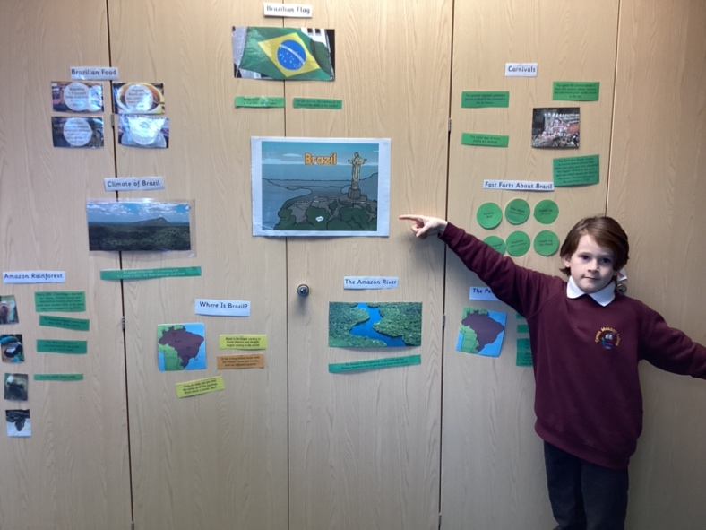 | 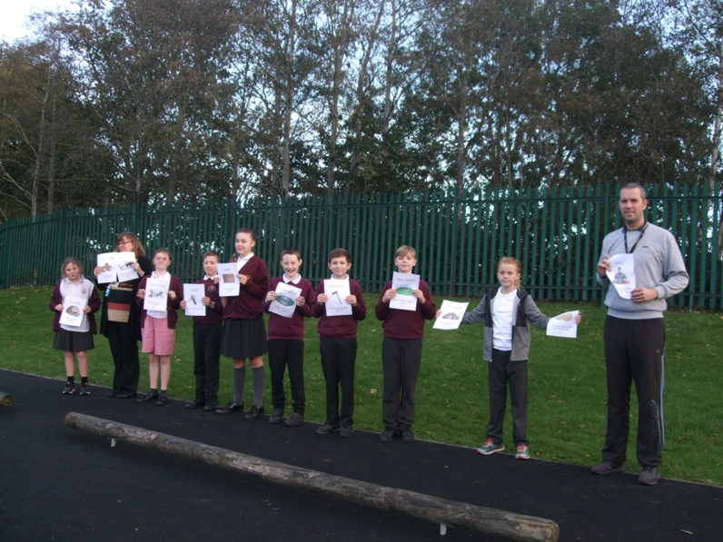

CPD
This year has seen me attend more professional Zoom meetings in the geography field. It would appear that this is becoming the norm, nowadays as it involves less time away from school/class and is ultimately convenient, negating the need to travel to Liverpool. I’m now able to attend three courses per academic year and I have the opportunity to discuss issues or topics and pose questions to my subject coordinator either while online or post presentation. The courses are very useful in keeping me up-to-date with policy, practice and resource shares with fellow practitioners.

Quality of teaching & learning
This year’s peer observations and book scrutinies have again demonstrated that we have gifted, enthusiastic, resourceful and highly motivating teachers and teaching assistants at Orrets. Geography is popular with our students precisely because the subject is delivered in an innovative and enthusiastic fashion. Pupils feel fully supported, they know what to do when they ‘hit a brick wall’ and are challenged to an appropriate level for their ability. Differentiation is a key part of lesson planning and delivery and each classes’ team of staff are distributed well to provide for their group. Consequently, pupils make steady, measured progress with regard to NC levels of attainment. Students expressed an interest in sharing their new knowledge. They are keen debaters and rather driven to learning about new countries, cultures and locating these on both maps and globes.
I have been able to attend peer observations with the following colleagues; Mrs Fleming, Ms O’Brien, Ms MacGregor, Mrs Walsh and Mr Saul and experienced first-hand the variety of skills, expertise and resources in the inventory of our staff. Orrets’ staff continue to provide immensely resourceful and imaginative sessions which help to enrich a subject which is already a firm favourite among students.
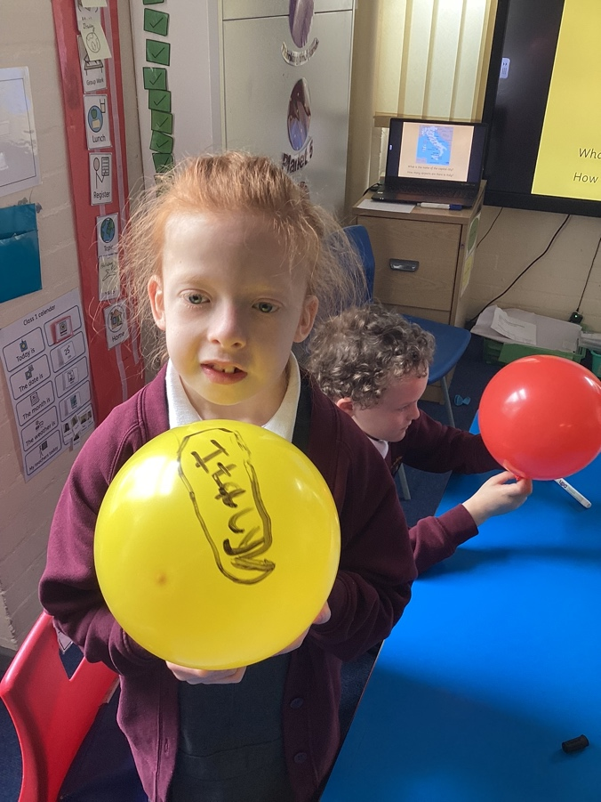 | 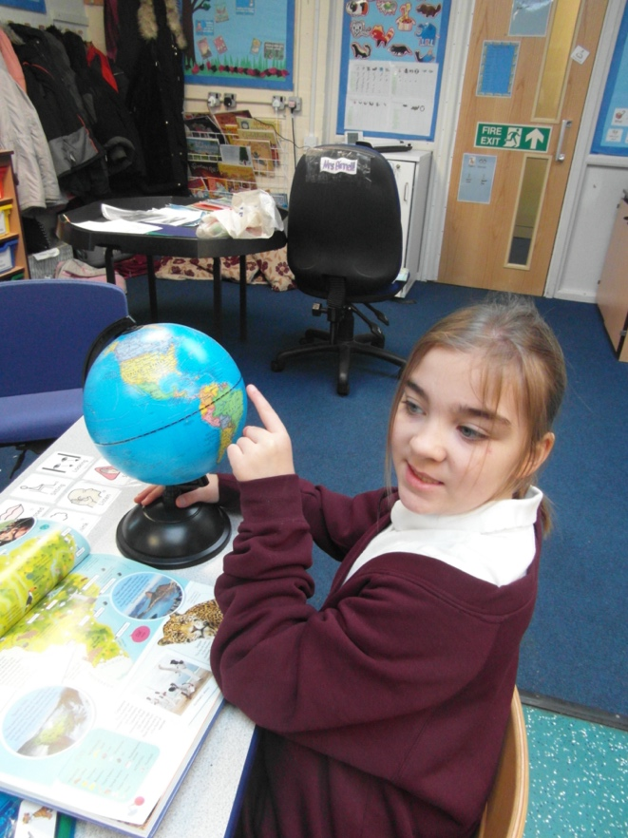

Reviews and survey samples
In last year’s report, I mentioned that Geography at Orrets Meadow had a higher status in popularity in relation to that perceived nationally and this favouring of the subject continues. There is a noticable trend in returning slightly higher teacher assessment grades in our online Trackzone decimal levels in Geography compared to that of History, but it would appear that this margin is being bridged. This has, in part, been facilitated by staff taking greater advantage of our ‘cultural capital’ pledge. The summer term provides the greatest opportunities for visits to such amazing venues as Port Sunlight, West Kirby Marina, Hoylake, Thurstaston Hill, Birkenhead Park, Docks and the oldest building in the entirety of Merseyside, The Birkenhead Priory. Opportunities to use our Ordnance Survey digital map subscription are used and mapping seems to be one of the most popular aspects of geography in our school (please refer to Pupil Voice samples, 2021 & 2022). Pupils’ Voice sample returns remain consistently positive with similar comments about the study of Geography.

Staff continue to use the Dimensions Trackzone assessment with ease while recording skill progression. Even at the lower end of the attainment scale, students can still be seen to achieve well and make steady progress.

Strengths in Geography
As with last year, staff perceived strengths in teaching Geography factored high in both subject knowledge and enjoyment. Students are comparatively more attuned to geographical content and terminology than since the last report. This is further corroboration of the assertion that Geography is popular among the school’s population. Teaching and learning support staff are adept at delivering inspiring lessons and even when the theme holds less geographical content, opportunities are taken to incorporate information where appropriate. Staff resourcefulness draws in geography content in all areas of teaching; drama, computing, fieldwork (even when not Geography focused) and physical multisensory strategies are employed. Technology is utilised more often to reinforce ‘sticky knowledge’; one example being a Kahoot quiz. Particularly useful as it seems less like a ‘test or assessment’ and more like a fun challenge.
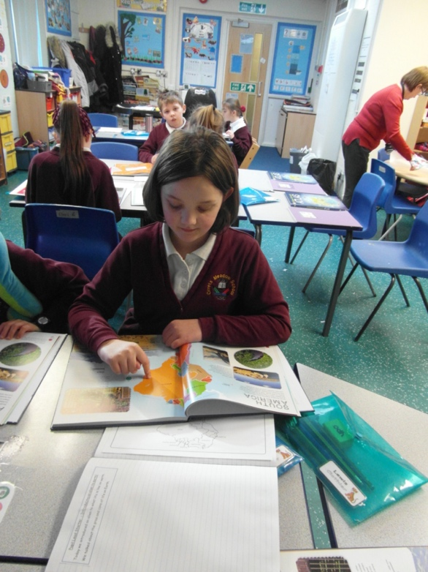 | 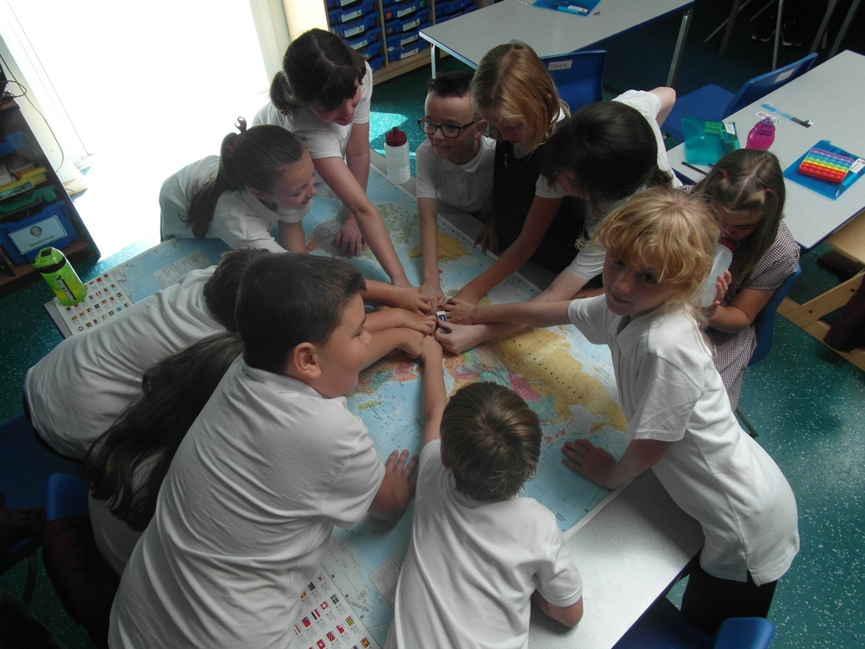

Ways forward
The staff survey samples provided a healthy, productive insight into how the teaching team understood they could move forward in Geography. We have fulfilled many ways forward from last year, particularly physical, multisensory resources such as inflatable globes for each child, more use of maps more widespread use of digital and computing technology, etc.

Next year, I have decided to focus partly on the continued push on certain areas (mapping, for example as OFSTED attach great importance to mapping in any and all forms. As a provision, I think we’re becoming quite seasoned in applying our knowledge and skills and indeed passing these onto our students. I intend to continue to encourage colleagues to use online resources more often. This provides our pupils with more tangible, physical and graphical options which have greater resonance with them.

It is intended that more opportunities will be taken to get out into the community and region on field trips. Summer term 2 is dedicated to the Wonders of Wirral and all focus areas are easily accessed via short minibus trips. With seven class groups climbing to eight in 2022-3, the bus will get plenty of use.

Targets for 2022-2023

- Greater use of maps (this continues to be both a priority and request by the student Spring 2)
- More ‘real-life’ resources (Contemporary equipment, eg: GPS, digital/technological etc. Spring 2)
- Encourage more digital and computer based resource use (Ordnance Survey, Garmin, etc.)
- Increase number of fieldwork trips (cultural capitol Summer 2)
- Expand the collaboration & sharing of resources (folders set up on school’s bank Spring 1)
- A large scale ‘class’ map (Spring 1)
- Produce a geography vocabulary dictionary coupled to year group levels (Spring 2)

