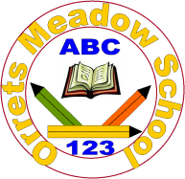
Governors Report – Summer 2021
Religious Education
Mrs Gordon
Achievements
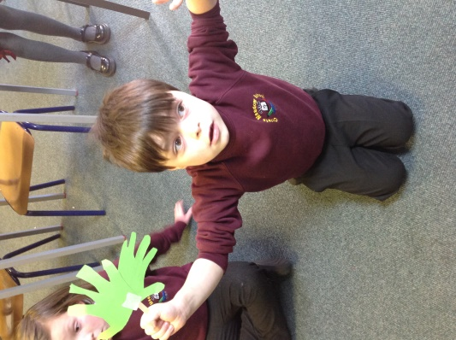
Despite a challenging year RE has continued to be successfully embedded into the afternoon curriculum with the teaching staff skilfully differentiating the subject’s knowledge and skills to meet the needs of each child.
Religion week was a great success! Each class were assigned a religion to study such as Islam, Hinduism, Sikhism, Buddhism and Judaism embrace through a range of creative routes such as singing, dancing, cooking, art work and role play. Each class produced a beautiful book of memories to record their learning during this week.
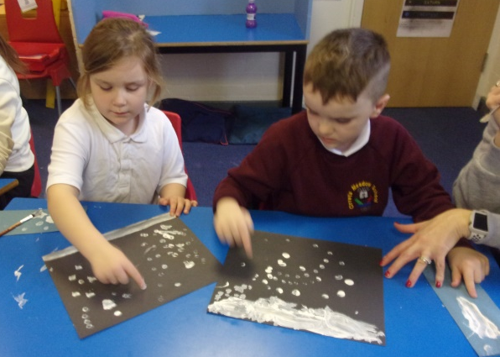
Christmas Week gave us exciting cultural opportunities to learn how Christmas is celebrated in different countries such as Russia, Sweden, Italy, Netherlands and Germany. We were also blessed to have our Christmas assembly with Reverend Graham Cousins via zoom!
As subject leader I am proud that these wonderful spiritual and cultural learning opportunities contribute to the schools thriving SMSC ethos.

Quality of teaching and learning
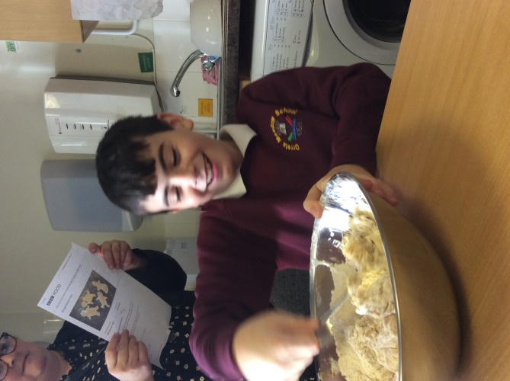
As subject leader I have completed a range of outcomes to oversee RE this year to ensure the high quality of teaching and learning. I have created a detailed and comprehensive subject leader file that contains the new RE policy and progression of skills that I created in June 2020. I have carried out a Year 6 lesson observation, staff and pupil voice including analysis. Book scrutiny in the first and last half term of RE teaching enabled me to monitor the quality and ensure teaching followed the long term plan accurately.
Finally I carried out a data analysis of progress across the school. From this I was able to see patterns in the data which showed how boys and pupil premium pupils made less progress in RE, therefore I will monitor this target group next year.

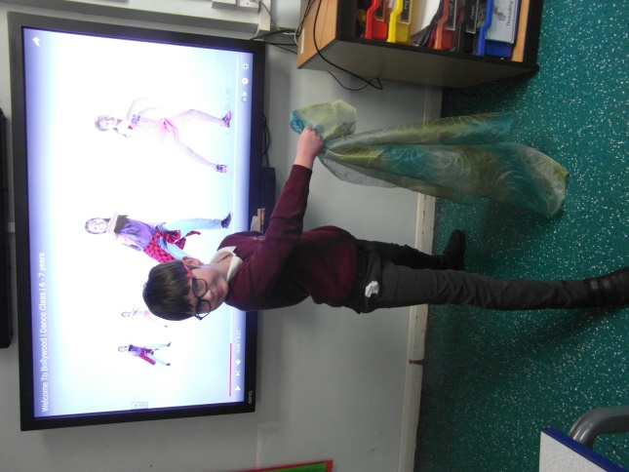
CPD
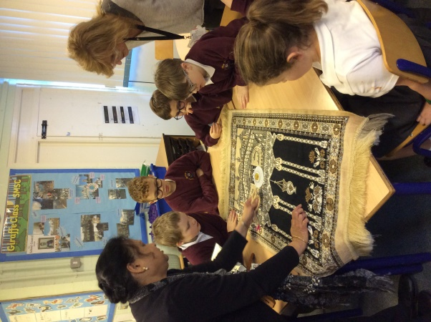
I am a member of the Wirral LTLRE HUB which is an excellent opportunity to keep in touch with the local RE subject leaders and share ideas and good practice. Through this channel I have accessed regular Zoom training meetings led by Wirral LTLRE HUB. These include Network meetings, Getting to the Heart of Islam, Getting to the heart of Christmas, Organising Big RE days in the Primary School and Exploring Passover through enriched learning. KS1 & 2. Teaching staff have been sign posted to relevant courses on Islam and Judaism.

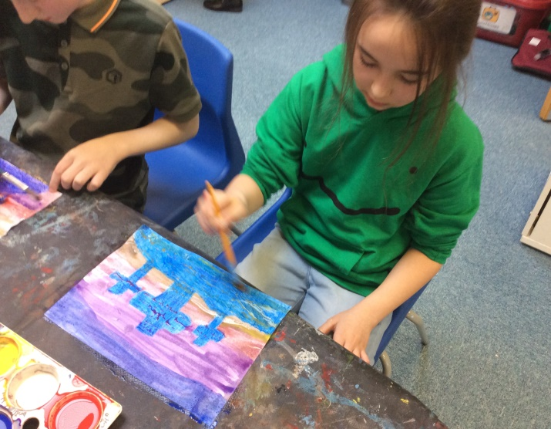
Strengths
The book scrutiny’s demonstrated how enthusiastic and receptive the pupils are to learning in RE. This is due to the creative approaches to teaching and excellent differentiation to the pupils’ levels. Pupils could verbalise what they have learnt and enjoyed in RE this year and a powerful 100% of pupils voiced they enjoyed their RE lessons. Staff were equally as positive through the staff voice questionnaire about their confidence in teaching RE, the excellent coverage over the year and the enjoyment of Religion and Christmas weeks.

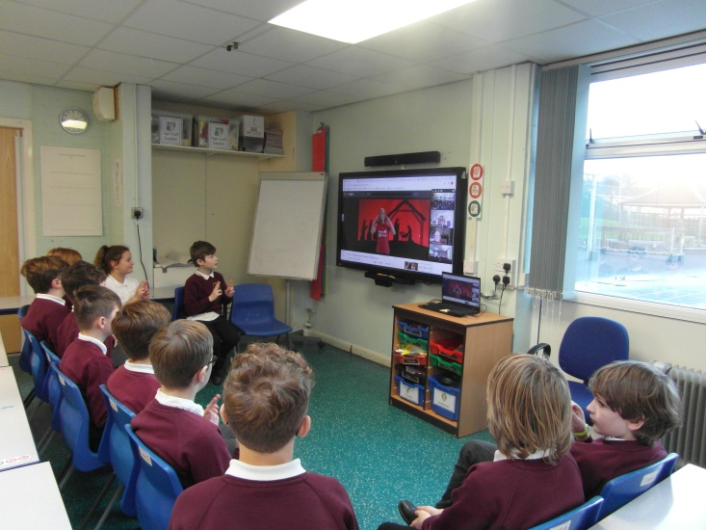
2021-2022 targets
• To promote holy days across the year. (One assembly per half term)
• To bring the RE curriculum to life through religious trips and experiences. (Across the year)
• To monitor boys and pupil premium groups progress in RE (February and July)
• To lead a staff meeting promoting sensory teaching strategies in RE (17/11/21)

