Governors Report – Summer 2023
Geography
Mr Eóin M Campbell

Achievements
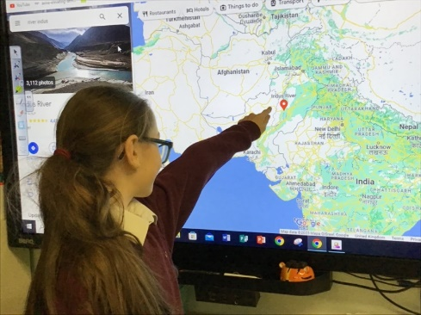
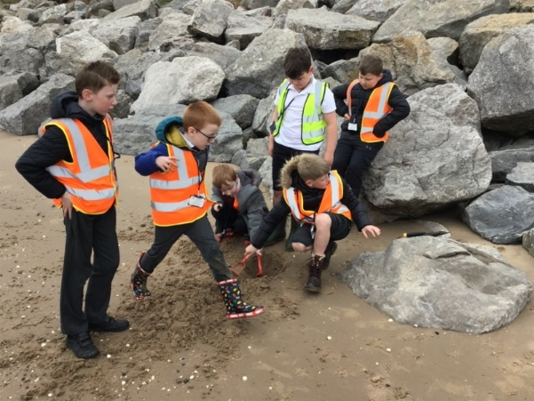
A few academic years on from Covid and Lockdown, and Orrets’ students have settled into a healthy routine of foundation subjects learning and Geography is certainly prominent in this respect. Geography remains a highly popular subject. The associated subject material, be that mapping, mountains, far off countries such as Fiji and its passion for rugby, Brazil’s amazing and vital rainforests and the locations of Scotland’s endangered animals closer to home along with the skills required of our children to research and learn about these appear not only challenges for our pupil population but also a powder keg of fascination in equal measure. The work produced, as evidenced in their books from the early years Wolves right up to the high flying Sharks is very impressive and clearly shows the enthusiasm for the subject. Quantitive successes are visible in the subject data analyses presented in each summer term. These scores demonstrate a measured success in Geography equivalent to and even in some cases exceeding those of other foundation subjects. Qualitative successes are far more enthusing for the teaching and educational staff at Orrets.

CPD
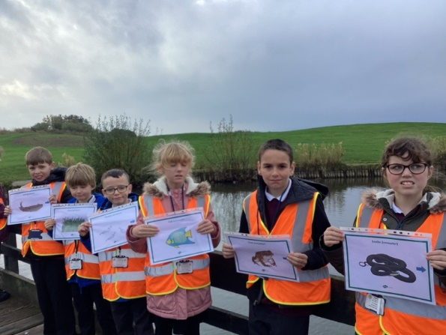
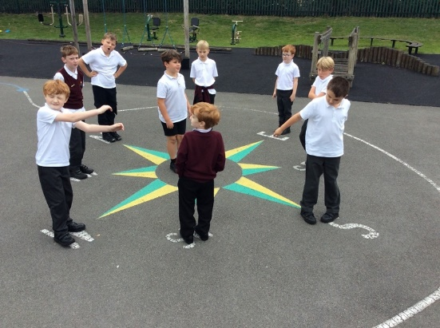
School has continued to be provide me with a healthy quota of Geography CPD, most notably my Merseyside hub Zoom sessions which continue to present me with up-to-date subject information as regards the Geography Primary curriculum. I’m also able to retrieve many new and alternative teaching strategies, skills and interventions. Although we have our global, holistic curriculum here at Orrets Meadow, the value of such interactive CPD and the subsequent information I draw from this is very helpful in preparing and presenting my numerous staff meetings throughout the academic year. These offer me the opportunity to impart this information to my colleagues; information pertaining to policy, practice and methodology. I have always understood the notion of an ‘open door’ attitude to any requests for alternative CPD and given the small size and tight budget a provision such as Orrets Meadow has, it is commendable that such requests may be entertained.

Quality of teaching & learning
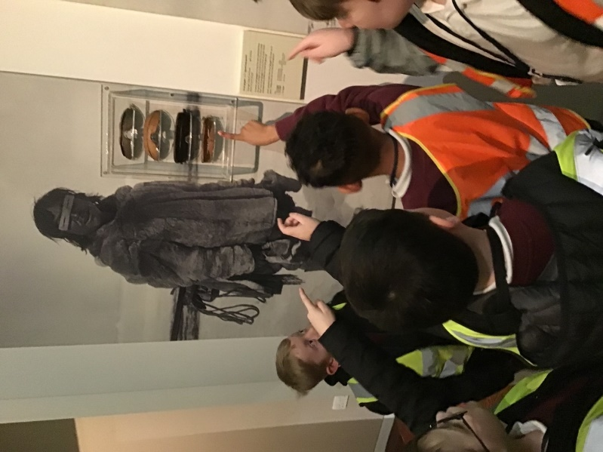
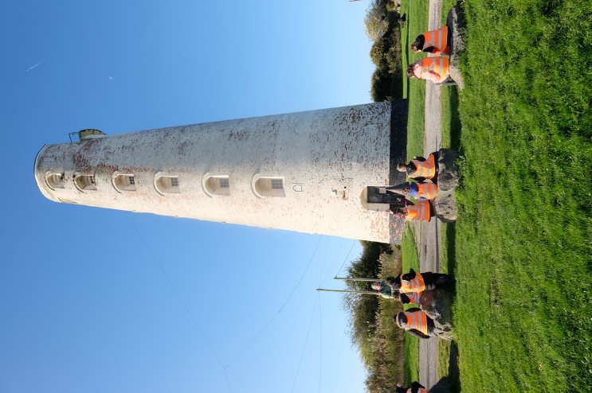
At Orrets, we subject leaders are given time off timetable to visit and observe classes’ lessons and carry out sporadic learning walks. It’s easy to experience a sense of ‘scrutiny’ for teachers in such circumstances and yet Orrets’ staff understand that the nature of my visits is purely to enjoy and absorb any given session’s Geographical content. We have a remarkable team of educators in our school and I never fail to learn new ‘stuff’ with every drop-in. Given the teacher assessment scores, the quality of teaching and resources provided that suit our very unique pupil population, the progress made is remarkable. Colleagues here learn about their student groups very quickly and are able to tailor and adapt sessions and tasks to each pupil’s particular needs and skills. Although much of our lesson planning is provided through the Dimensions Curriculum hub, this only scratches the surface of the preparation and planning undertaken by colleagues. Tasks are made as multisensory as possible, as it is fundamentally understood that the best way to learn is through physical, practical experience rather than merely writing, typing or regurgitating. Consequently, Orrets Meadow is now into its second year of National Trust membership. This provides the school with the opportunity to visit any number of historical venues such as Speke Hall, Styal Mill and even the homes of the Beatles in Liverpool. On asking colleagues to recall trips they experienced when they attended school, the vivid memories of such outings were still etched in their minds, even up to and beyond fifty years after the actual event. Is there any better form of sticky knowledge? The extended and enriching knowledge staff then passes on to our pupils and the cross curricular opportunities are limitless.

Reviews and survey samples
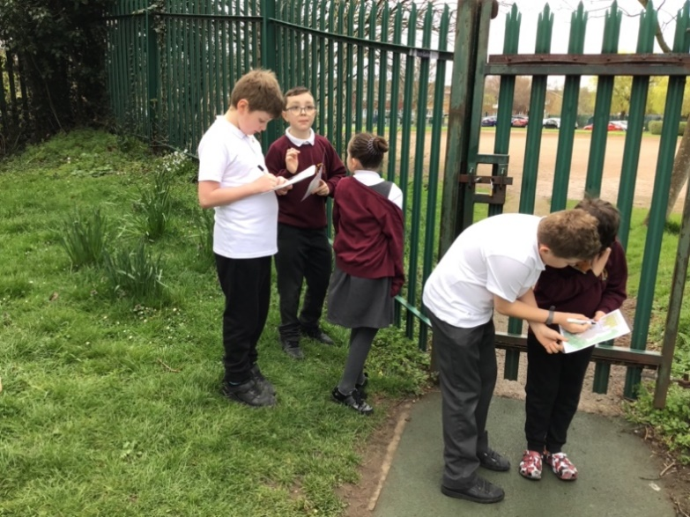
The most valuable sources of information feedback are the pupil and staff voices in Geography. These two survey samples inform me on ways forward and a synopsis of opinion on my subject specialism. If the popularity of History and our children’s motivation and preparedness to learn are understood and digested, then the stage is set to move forward in seeking newer or other tried and trusted ways to feed this enthusiasm. As previously noted, Geography continues to be a very popular subject area of learning here at Orrets. To any outsider, Dimensions may seem to ‘melange’ foundation learning from autonomous subject domains into a blended seamless entity that can potentially leave students unclear about the specific subject they’re engaging in, in any given lesson. Yet when reviewing the pupil voices rendered this year, it’s abundantly clear that children can see clearly and report back numerous aspects of Geographical content they’ve been exposed to. Whenever Geography is any given lesson’s topic of study, it is noted and labelled so anyone viewing a student’s exercise book can distinguish this clearly. Students are very clear on how to go about seeking advice and support and from the same survey samples, the overriding sense of not being phased or anxious about being stuck is ever-present. Asking for help and support is simply the way it is in our school and children have no apprehension about doing so. Children know they are expected and encouraged to seek guidance. Children happily discuss their learning on returning home, which is a marvellous affirmation of the subject’s popularity and the indelible mark it leaves on them.

Strengths in Geography
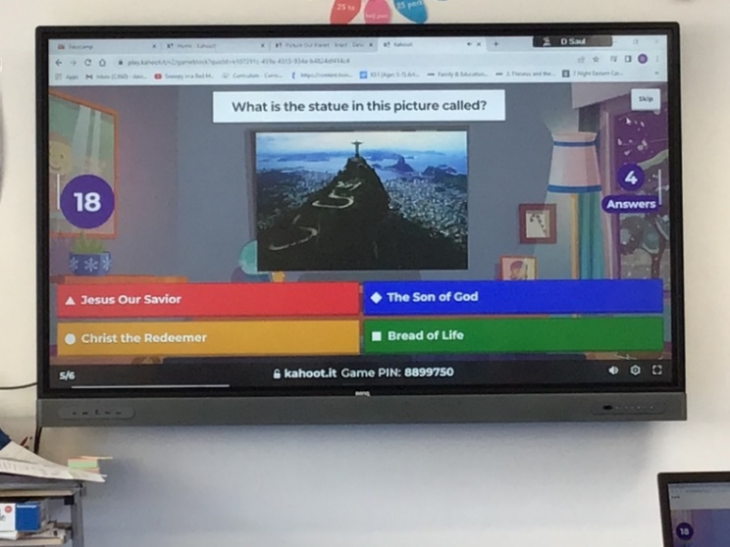
When weighing up the feedback from colleagues, be this orally in day-to-day conversation, textually through surveys or during staff meetings, it’s apparent that Geography is a very popular subject area for teachers within our Dimensions Curriculum. The early days of adjusting to a holistic from an autonomous methodology are now a routinely entrenched. Staff can pick out specific aspects of geographical study and recount experiences of their given group’s learning, their strengths and needs or ways forward. The ‘where, how, why, when & what’ approach to informing, discussing and eliciting responses is not simply a tried and tested formula but one which suits our pupil population perfectly. It’s a great guideline that meets the needs of our children. They seem to know where they are.

Ways forward
Now that we are into our second year of National Trust membership, I intend that we begin to utilise this as fully as possible. The revision and enrichment of the current education packs provides staff with a number of ideas for them to prepare and conduct their visit. Now that educational visits and trips are becoming more and more common and a staple part of Orrets learning ‘diet’, it’s important to remember that although a fantastic and exciting experience to compliment learning, it is in essence and educational experience. It may be possible to focus trips purely on historical content and yet the opportunity to enrich a global learning experience of foundation and core subjects should not be missed.
Orrets staff are some of the most imaginative and resourceful people one could ever meet in an educational environment and therefore, seeking their counsel on improving the history experience here is an absolute must.

Targets for 2023-2024
The staff survey samples provided a healthy, productive insight into how the teaching team understood they could move forward in Geography. The following is a short, concise list of some of these proposals:
- Highlight the geographical aspects of our Wonders of Wirral module in the Summer 2 term to cover NC Geography skills and knowledge and provide teaching teams with an opportunity to plug any learning gaps that may have emerged through the course of the year.
- Continue encourage greater use of National Trust membership with a Geographical focus
- Revise the ‘education packs’ for cultural capital venues & seek feedback from staff regarding their use for and at given NT locations.
- Explore cross curricular opportunities that will enrich the learning of Geography.
- Attend more CPD courses in History 2023-24

