Governors Report – Summer 2023
Maths
Lorna Billington
Intent:
The focus of the whole school this year was develop the children’s ability to ‘solve problems’.
School Development Plan
Focused Priority 4 | Title | Further develop pupils’ ability to solve mathematical problems
Pupil Voice and Staff discussions have raised the difficulties that children face when attempting ‘problem solving’. This is a combination of co-morbidities (ADHD, ASD, language and processing). This year we have focused on solving problems and enhanced application through a review of strategies, training and resources.
Questions to address during the year:
• Are pupils confident with Maths language and vocabulary?
• Have pupils had a range of strategies to solve problems?
• Have pupils had experience of a wide range of problems to solve?
• Have pupils learned stem sentences to support recall and explanations?
• Have staff been trained on problem solving strategies and maths language and questioning?

Why should children develop problem solving skills?
Problem-Solving Skills Build Confidence OFSTED REPORT / NC
Typically, effective problem-solving skills result in “happier, more confident, and more independent individuals”. When children tackle problems on their own, or in a group, they become resilient. They learn to look at challenges from a fresh perspective.
Children develop problem-solving skills at different rates; nevertheless, it is imperative that children learn to tackle problems with grit and creativity, especially as they learn to cope with setbacks or resolve conflict. Moreover, problem solving is one of the most important skills children can develop, because it prepares them to face increasingly complex academic and interpersonal issues as they mature.

Experts agree that the ability to meet challenges confidently is “a critical skill for school readiness.” In many cases, children learn by watching parents or caregivers solve problems.
Implementation
A range of initiatives were incorporated into the school year to support our aim:
OFSTED New terminology
- Declarative knowledge – this consists of facts, formulae, concepts, principles and rules; it can be prefaced with the sentence stem, ‘I know that…’.
- Procedural knowledge – this involves recall as a sequence of steps. This category includes methods , algorithms and procedures, for example for long division or multiplication. It can be prefaced with the sentence stem, ‘I know how…’.
- Conditional knowledge – this gives pupils the ability to reason and solve problems, using declarative and procedural knowledge to choose successful strategies. It can be prefaced with the sentence stem, ‘I know when…’

All staff have been made laminated bubbles to display in class to support the implementation of this new terminology and to begin questioning pupils that reflects the new terminology involved.
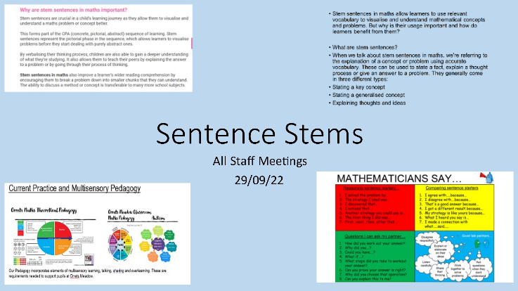
Staff Training / meetings:

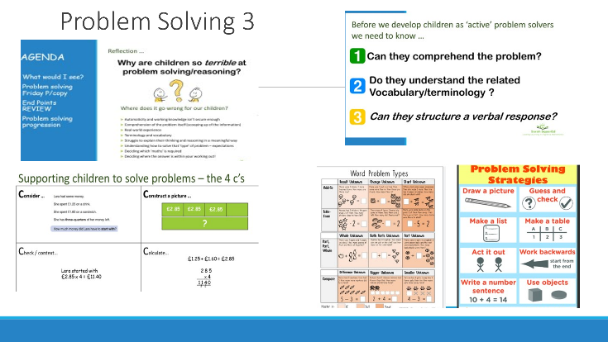

Staff Meetings foci: Declarative knowledge / Procedural knowledge Conditional Knowledge
Why do pupils our pupils find it difficult? Theory of problem solving. Types of problems. Strategies and support. Pedagogy theory and practise. White rose hub CPD online training. National Curriculum Progression of ‘Problem solving’. Language and stem sentences.

Maths through ‘Story Books’ This year we have introduced a small selection of story books aimed at promoting maths through discussion, question and answer through the medium of a shared story. This has been well received and both staff and children alike have really enjoyed the sessions. As a result we would like to extend our ‘maths story’ library in the coming year.

Progression: problem solving: In order to teach problem solving in line with the National Curriculum I collated the objectives for Problem solving across all strands of maths, this was a focus at one of the staff meetings. Staff were given time to link their classes to the progressional steps. (Table below is an example)

Discrete fluency lessons have continued this year and been well received with staff stating that children are making observed progress as a result. Staff voice stated that having a discrete allocated time to focus on problem solving has supported progress effectively not just in maths but has transferred across other subjects.
Mental Maths Bonds Arithmetic Fluency 10:45-11am
Monday | Tuesday | Wednesday | Thursday | Friday
Multiplication/Division  Facts and relationships | Addition and subtraction  Relationships | Multiplication and Division  Recall Fluency | Number Bonds  Inverse relationships | Problem solving  Friday

‘Ready to Progress’
As a result of covid the ready to progress document is still considered but incorporated into our development and planning.
Our school pedagogy for maths has played an integral part in our development of maths and continues to support our pupils through a multisensory approach.

CPD : Staff Meeting:
Courses: I have continued to attended maths subject leader courses as facilitated through ‘Sarah Squared’. These include the latest findings, updates, advice and recommendations. Staff meeting reflect advice shared at these meetings.
STAFF CPD
This year we have continued funding for maths to buy in: White Rose Hub Staff training. The training is directly related to the application of the National curriculum objectives as presented through The White Rose Hub.
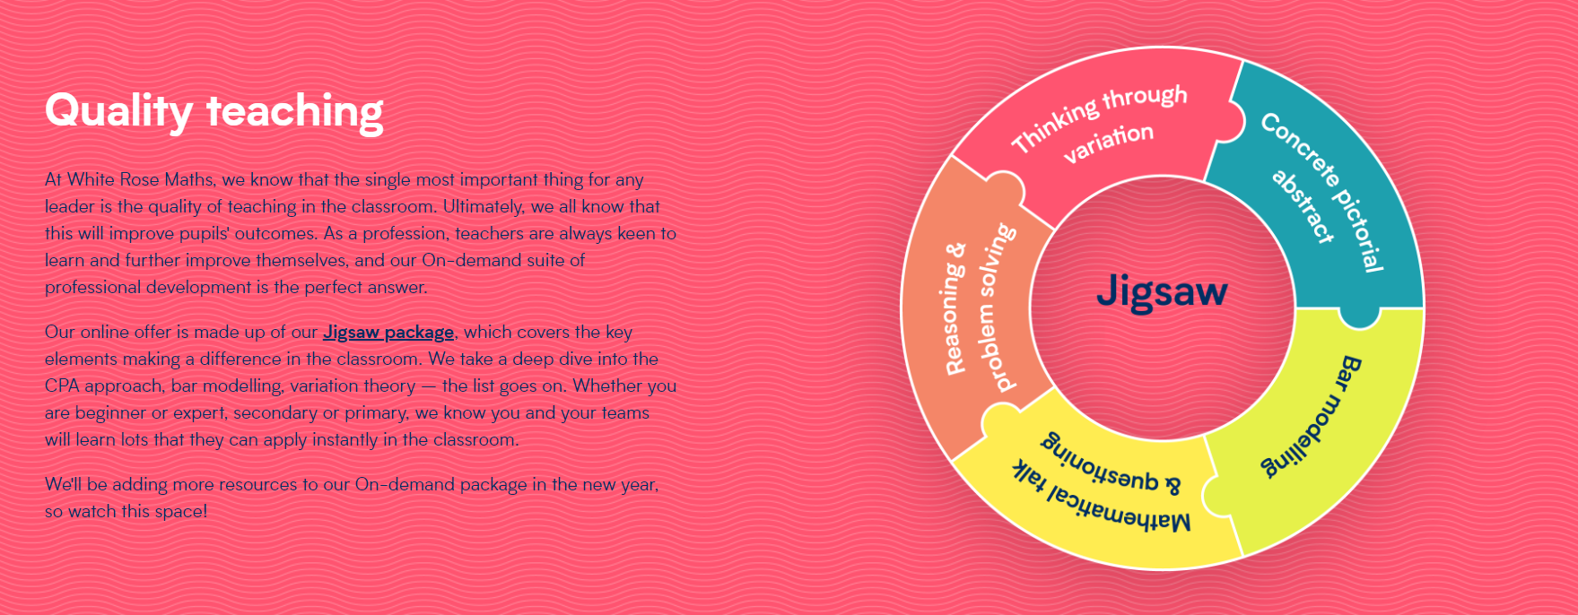
All staff have an individual log in which allows them to work through sections of online training to support their needs.

MATHS MODERATION
Within School we carry out maths moderation. Here all teachers attend and bring with them work from their class to share and moderate according to the National Curriculum objectives. Teachers discuss the pupil as a whole and reflect on how the pupil has met the objectives and address any worries or concerns related to their additional needs.

Quality of teaching learning : Assessment / Review
Impact
Pupil voice demonstrated that all children had really enjoyed their ‘Problem solving’ lessons. They felt more confident when approaching problems. Children, during ‘pupil voice’ interviews were encouraged to show me work they enjoyed and work they were proud of. All children referred to work on problems and talked about how they really liked maths because it was fun and a challenge. This is just what we want to achieve for our pupils, a fun interactive maths session to support their ‘real life skills and understanding of the world.
Staff voice:

Assessment
This continues to be made through Assertive mentoring and the White Rose Hub assessments at the end of each term. We also assess mental maths using ‘Animals Awards’.
Learning Walks : Stem sentences, problem solving as well as fluency have been a focus. Walks have continued this year and have evidenced continued excellent practise in all areas.

Book Scrutiny
Focussed on the school marking approach, Stem sentences and problem solving, work produced, presentation and progression. The books clearly evidenced hard work good progress and lots of approaches to problem solving work.
Strengths:
- Pupils make progress. (Assessment data raw scores/ Assessing pupil progress / Pupil progress/ observations/ book scrutiny/ staff voice/ pupil voice).
- Pupil’s ability to solve problems has developed and progress has been made. This has been evidence through Teacher and pupil voice.
- The staff continue to feel confident delivering a range of activities to meet the diverse needs of our pupils. The staff feel that the White Rose Hub programme of study along with extras from a range of sources supports teaching and learning.
- Real life maths continues to be well supported through maths, social skills and life skills.
- Talking Maths and Stem sentence support, continues to play an active role during maths lessons and has been well delivered and supported to ensure our pupils’ understanding and application of maths.
- Fluency is discretely taught with a focus this year on ‘problem solving Friday’
- Whole staff CPD has been put in place and well received.
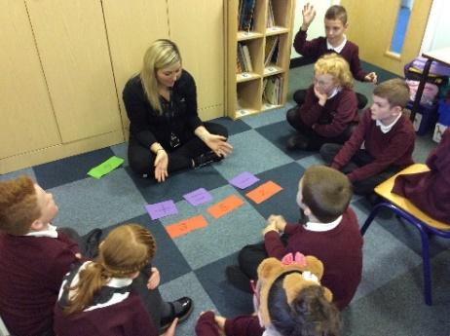
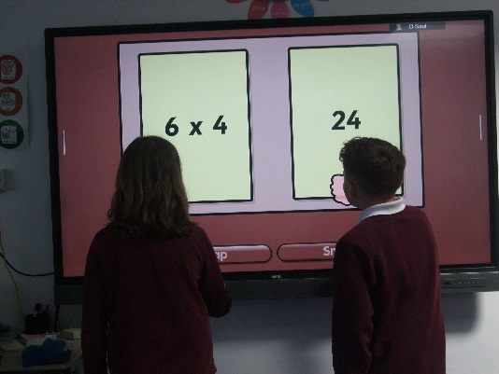
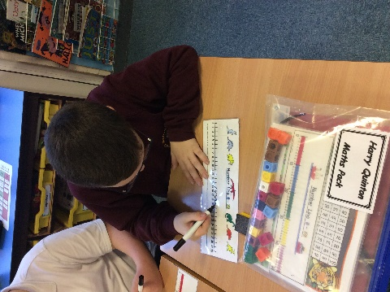

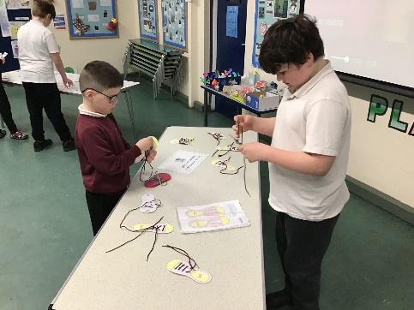

Examples of solving problems within a maths lesson and outside of a maths lesson.

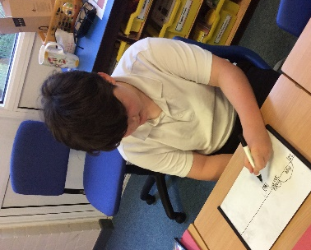
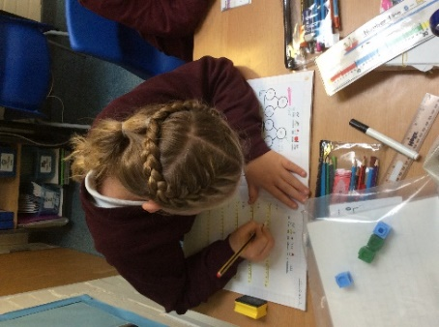
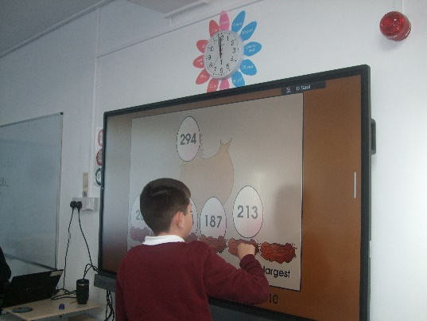
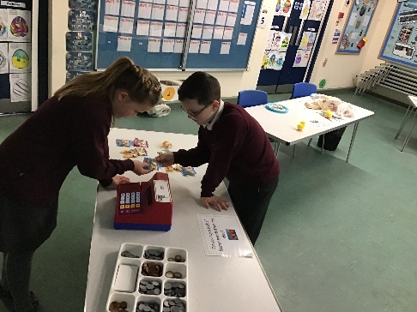
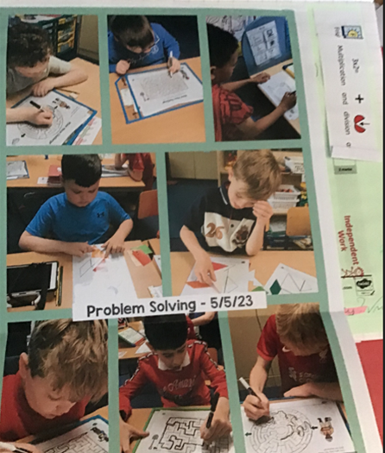
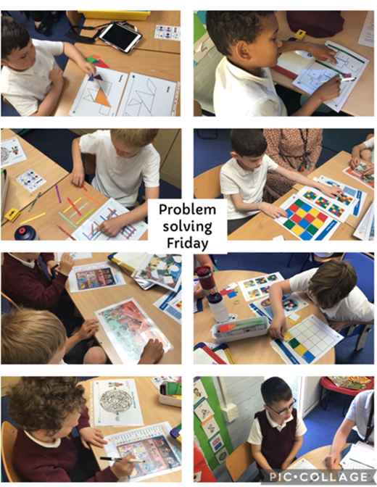
Governor Visits
It has been lovely to meet with Mrs Cooper during the year to share classroom practice, the children’s work, updates and initiatives. Mrs Cooper is always enthusiastic about our school and the progress made by pupils. Mrs Cooper plays the role of a critical partner and always questions what, how, why and when we do things having the children’s experiences and support as a focus. School continues to really value our close links with our governors and the support they give us.

Ways forward
As the school cohort continues to change and a greater proportion of pupils with speech, processing, language and communication difficulties are attending the school, the impact of such difficulties continues to be an ongoing need that the school must continually address. As a result I intend to reflect the growing needs of pupils’ through changes to our school long term plans. We have more children working at lower levels proceeding through to higher age/ year groups. With this in mind it becomes more important that more coverage is given to the basics throughout each term. This is the focus of the changes. It will ensure that all pupils will have access to a greater degree of overlearning. As a school we also feel that the steps curriculum is now playing a bigger part in our planning and overall development as more pupils are moving through school whilst still in the ‘steps’ development stage. With this in mind, I would like to define in greater detail the learning / objective steps within each stage of the ‘steps’ curriculum. This will be another focus.

Thank you for your time and continued support.
Lorna Billington

Appendix 1 - Review of Maths input via School Development Plans since the last OFSTED
SDP | Focus
2017 -2018  Background priority 1 | To extend children’s mathematical skills with a focus on measure, mental maths and problem solving strategies. | FOCUS: MASTERY WRH introduction/trial ASSERTIVE MATHS  - 15 MINS additional intervention each day  -Staff training INSET Mastery in Maths.  -Onset of WRH monitoring.  -Mastery of subtraction and division.  -Focus of Assertive mentoring tests weekly.  - Summer term introduction of discrete 15 mins mental maths (multiplication) session.
2018 – 2019  Focused Priority 3 | To further develop the mastery of maths at OM across the school, including the mastery of times tables and arithmetic skills. | FOCUS: Embedding WRH mastery curriculum  -Review of last year’s introduction of WRH.  -Staff meeting /training: Arithmetic: Methods and questions expectations of the four operations.  -P levels cluster group to ensure moderation across schools for P levels.  -Scrutiny linking learning objectives to WRH  - reviews and assessment of multiplication demonstrated progress and engagement  -evidenced in staff and pupil surveys.
2019-2020  Focused priority 4 | Develop real life skills of money, time and measure to increase mastery in Maths and social skills of our pupils.  Orrets Meadow follows a structured learning programme supported by the White Rose Hub for Mathematics. In light of our new pupil cohorts we wish to facilitate a greater emphasis on life skills. | FOCUS: REAL LIFE MATHS  -TAs Numicon – Training  -Staff Meeting REAL LIFE MATHs  -Amended the WRH to meet the needs of our SEN pupils in light of REAL- LIFE maths.  - Staff training REAL LIFE Maths.  -Sarah squared – moderation and subject leads
2020- 2021  Focused priority 4 | As above continued due to lockdown. | FOCUS: continued REAL LIFE MATHS  - READY TO PROGRESS CRITERIA  - REAL LIFE parent support group  - REAL LIFE opportunity in class shop measure etc
2021 -2022  Focused Priority 4 | To reinforce mathematics through: supporting, monitoring and developing the use of mathematical vocabulary throughout the maths lesson. | FOCUS: The LANGUAGE OF MATHS  -Staff Meeting : Vocabulary; the language of maths.  -Ready to progress criteria update.  -STAFF Training on the language of maths progression throughout KS1 and KS2 – Sarah T  - Mathematical vocabulary / parent workshop  -introduction of Talking maths as an additional needs intervention.  -Planning addition of READY TO PROGRESS  - Maths language identification for lessons.  - Change to the 15 minute session:now integrating multiplication, division addition and subtraction /fact families /bonds and problem solving to enhance the development of fluency.
2022 – 2023  Focused Priority 3 | Further develop pupils’ ability to solve mathematical problems | FOCUS: Problem Solving  •Staff Voice supported fully and agreed that as a result of CPD(staff meeting) Problem solving all the bullet points had been met effectively (see responses) and contributed to observed progress and development of the pupils responses to ‘ solving problems’ .  •Pupil voice highlighted pupil enjoyment of problem solving. Children enjoy a challenge and shared that they were proud when they achieved a tricky problem. All pupils felt they had got much better at solving problems.  •Staff meetings on language and vocabulary continuation from last year ‘Total communication’ / talking maths.  •Class language dictionaries to support language development.  •Staff Training: All teachers and teaching assistant staff trained on stem sentences.  •CPD staff meetings focus: Problem solving.  •Five staff meetings focusing on theory, strategies and implementation for pupils with SEN.  •The introduction of learning maths through a story book. (books resourced)  •Staff governor report: meetings took place to update and explore questions. (see governor report).  •APP / Pupil progress / Assertive maths

Appendix 2 - Review of ORRETS MEADOW MATHS Application in light of recent OFSTED review.
Summary of Maths Research Review/Notes for Subject Action Plan
Mathematics

Pupils are more likely to develop a positive attitude towards mathematics if they are successful in it, especially if they are aware of this success. The report indicates that teachers should be aware of this process and avoid the use of games to motivate students. When a pupil becomes anxious about mathematics, this is not because of the subject but is instead due to their failure to acquire knowledge. Once pupils acquire core knowledge, it is likely that they will associate the subject with enjoyment and success. We should be aware of the differences between infrequent mistakes and consistent mistakes that are likely to make pupils anxious about maths. Consistent mistakes are likely to be caused by weak foundational knowledge. A proficiency first approach is likely to prevent students from becoming anxious.

The report also focuses on the importance of early acquisition of knowledge and how that can impact on later success. By securing core facts at an early age, children are less likely to overload their working memory and are able to acquire confidence in and enjoyment of maths.
New terminology

- Declarative knowledge – this consists of facts, formulae, concepts, principles and rules; it can be prefaced with the sentence stem, ‘I know that…’.
- Procedural knowledge – this involves recall as a sequence of steps. This category includes methods, algorithms and procedures, for example for long division or multiplication. It can be prefaced with the sentence stem, ‘I know how…’.
- Conditional knowledge – this gives pupils the ability to reason and solve problems, using declarative and procedural knowledge to choose successful strategies. It can be prefaced with the sentence stem, ‘I know when…’

Key headlines from document | What do we already have in place? | Continued action and How can we improve? (Suggestions for the action plan)
Curriculum progression is planned from the beginning of a pupil’s education through focusing on core content, to develop pupils’ motivation and to allow more breadth and depth later.  The planned curriculum details the core facts, concepts, methods and strategies that give pupils the best chance of succeeding in the subject. | We use primarily White Rose Hub, a DfE approved scheme to support the delivery of our mathematics curriculum. This incorporates planned progression through year groups.  Core facts are taught in all year groups through fluency lessons.  A fifteen minute slot (10:45 -11 AM ) is dedicated to the enhancement of multiplication and mental maths facts fluency.  During this time pupils are engaged in active maths, singing, and shared activities.  Initial testing on entry to Orrets meadow involves an Assertive mentoring test or Teacher assessment depending on the ability of the child.  Throughout the pupil’s journey through Orrets Meadow children are assessed by initially assertive mentoring test as well as end of block White Rose Hub tests. Weekly assessment sare used to reinforce and diagnose areas that need support. | Review of fluency provision throughout school.  Learning walks  Book scrutiny.  22-23 Discrete fluency lessons are now embedded into maths lessons. On a Friday during fluency time the focus is ‘Problem Solving’.  Opportunities for problem solving explored and embedded within the wider curriculum.
Schools should prioritise children’s enjoyment of maths which will lead to a positive attitude and decreased anxiety about the subject.  There should be less emphasis on ‘learning through mistakes’ and more emphasis on securing early sound foundations in core knowledge. | All pupils are assessed to establish areas that needs support. Pupils in classes are regularly reviewed through testing and pupil progress meetings.  Pupils are taught at the levels assessed and the curriculum is amended. Therefore, a pupil who is chronologically aged at year 3 for example but working at Step 6 will be taught at step 6.  Small classes and a high proportion of TA support allows for this pupil centred approach.  Basic maths skills are reinforced through class lessons. Time is given for pupils to share paired and group activities as well as songs and games.  Mathletics /purple mash/ Education City and other online games are used to enhance and support the love of maths. Pupils are supported in these activities. | Pupils are given a wide maths curriculum and interactive lessons presented in a calm learning environment. Children are frequently asked about their views and through the ‘Zones of Regulation’ pupils can voice their opinions, thoughts and feelings.  22-23 Pupil voice  All pupils expressed how much they enjoy their maths lessons.  Staff voice expressed that staff felt confident and well supported. Regular learning walks and lesson observations.  Class cohorts  Pupil progress meetings
Declarative knowledge should be prioritised particularly in EYFS and Year 1. Gaps which children arrive with (for example those children who have not encountered early maths concepts before starting school) should be identified and filled early in a child’s school life. | Children have access to a maths rich environment in all classes through their lessons.  Resources are updated when requested.  Oral fluency Maths language and communication is prioritised through ‘Talking Maths’ Additional needs groups and enhancement of all maths lessons with a Talking maths approach.  (Training Sept 21)  5 fluency sessions per week support fluency, basic skills and shared problem solving throughout each week.  Animal Awards encourage and enhance development of mental maths and fluency. Children are rewarded with certificates of achievement and they progress through each award.  Where a child’s need is such that to achieve a full award is too much awards are broken down into smaller learning goals to ensure the sense of progression and achievement is continued. | Investment during Covid in Education City and renewed use of Mathletics and Purple mash support learning and reinforcement both at home and at school.  22-23 Staff training has focused problem solving, questioning, the use of Stem sentences and learning through story books. The use of declarative, conditional and procedural questioning is part of each lesson.
Procedural knowledge - as children progress through school they should rely less and less on visual resources and manipulatives and move towards abstract representations | Due to the nature of our pupils’ it does not always follow that the older they get the less manipulatives or practical resources they use.  It may be that children use a decreasing number of manipulatives as their understanding increases.  At Orrets Meadow many children may continue to need visual prompts, practical resources and manipulatives throughout their time at school, depending on their social, communication and academic stages.  Mental maths approaches and maths strategies do not follow a year group link but will be dependent on the needs of pupil’s not year groups. | Continue to ensure calculation policy is representing practice in each year group and that all teaching and learning staff are aware of its contents.
Conditional knowledge – do children have the strategies to help them unpick mathematical problems and then solve them?  Strategies should be taught explicitly to children to avoid strategies such as ‘trial and ‘error’. | Problem solving is taught through delivery of the White Rose hub Scheme. The mastery and depth of lessons is observed and differentiated by staff who know their classes well. The White rose Hub scheme facilitates overlearning and reviews of a range of strategies to support basic understanding.  Ready to progress criteria and maths pedagogy are regularly discussed at Staff meetings.  In school moderation has always and will continue to take place. Regular Moderation involving cluster groups including mainstream and special schools took place regualry. This will hopefully start up again as the Covid crisis lessens.  Years 1-6 are using Ready to Progress materials to ensure that children are being taught the correct word problems which will enable them to access the next year group’s learning.  This is taken into account during planning.  Children working at a Pre NC level use STEPS to ensure progression of skills. Where pupils have a spiky profile Teachers may use objectives from later or previous year group objectives to ensure that gaps are being met and reinforced.  . | Continued regular Maths Staff meeting and CPD when required.  Book scrutinies and discussions with staff  Moderation exercises.  Learning walks.
Make sure children have the time to fully grasp core concepts. Do not rush them through ‘tasks’ – make sure their learning is secure. | Small class sizes and a curriculum led by pupil need is established at Orrets Meadow.  Overlearning and reinforcement is a priority due to the nature and needs of the pupils.  Work is differentiated and learning supported by TA’s  Introduction of Talking Maths as a whole school intervention to support the language of maths. This is through practical lessons as well as specific individualised groups for additional needs. | Continued use of Talking maths during lessons and through additional needs interventions.  The use of stem sentences.  Learning walks /observation
Teachers should plan frequent, low-stakes testing to help pupils to remember content and lessons incorporate timed testing to help pupils learn maths facts to automaticity. (these should not be conflated with past papers). | Currently all pupils are assessed using assertive maths mentoring weekly for diagnostic purposes and end of term White Rose Hub tests to again assess a pupils gaps in progression and learning. | Continue to use teacher voice to establish where and when such assessments could be used.
Textbooks/Workbooks can be a valuable way for lower attaining children to practice their maths. This can work well when books are sent home for practice to be continued there. Does not have to be the scheme book used in class. | Due to the nature and needs of the children White Rose Hub objectives and scheme are used in conjunction with a range of other resources included Teacher created work, activities and worksheets. | Continue to reinforce work through homework for those who can access it.  Considerations for Parental special needs. / child parent mental health / ASD conditions / social communication needs.
Clear expectations of presentation should be established for calculations – children are less likely to make mistakes and more likely to spot patterns if presentation is systematic. | Class lessons use clear strategies: Part whole model/Bar model/number line, as well as those set out in the calculation policy. | Continue to ensure consistency through book monitoring.
Opportunities should be created to support ECT teachers and to make sure staff knowledge is up to date. | Regular Staff meetings and Requests for training.  Training from Specialist providers Sarah Squared.  Maths Lead attends Regular Maths updates and cascades information to all staff. | Continue to enhance teaching through support and regular discussions at maths staff meetings.

