Governor Report- Summer 2021
Music
Charlotte O’Brien
Achievements
‘Musical Monday’s’ have been a wonderful opportunity for the children to access a wide range of genres and styles of music via Zoom during COVID restrictions. Amongst others they have heard from Meera and Dom, who took them through a magical flute and piano Liverbird journey and they have learnt to beatbox with accomplished Beatbox performer and DJ Dean Yhnell who was also kind enough to share his story of struggling in school with ADHD and Tourette’s syndrome before finding beatboxing, which resonated with our children and staff.
In April the Bears and the Owls took part in the Amasing Sing ‘Thousand Bubbles’ online choir joining thousands of other children to sing ‘Let’s build a world’ and ‘Chester Zoo: Sustainability’ songs about the climate change and recycling.
In June the Foxes, Sharks, Tigers and Owls enjoyed a live, in person concert from Ben Sayah through the Cultural Recovery Funds return to live music funding. He sang and played guitar music through the ages and sing-a-log hits for the children to join in. He even composed a blues song based on what they ate for breakfast!
Over the year children have accessed a wide range of songs and music from across the world via the Dimensions curriculum. The books scrutinies completed each term show progress across the school that meets the objectives of the National Curriculum.
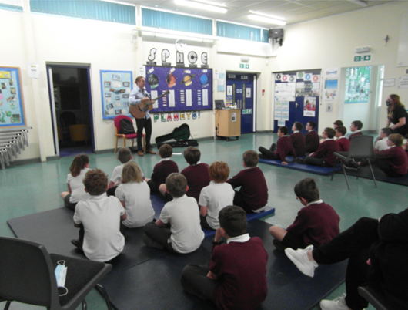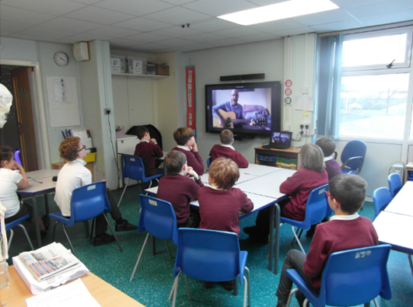
CPD
In the last year I have had the opportunity to complete the ‘Understanding Musical Learning’ self-taught course offered by Music Education Solutions a highly recommended website providing CPD for teachers. It was interesting to explore concepts of direct instruction verses enculturation as formal and informal methods of teaching music.
I have also taken part in an ‘Introduction to Body Percussion’ course. Further staff training could make Body Percussion an interesting way to enhance the delivery of our Dimensions Curriculum.
The Model Music Curriculum was published in March 2021. It emphasises music through history which is not covered by the Dimensions Curriculum. A music spine for each class to listen too during the year, either as an activity or as calming incidental music would boarded the children’s experiences of music through time.

Quality of teaching and learning
To monitor the quality of teaching and learning in Music, a Music Leader’s file has been created to organise all the relevant policies and documents into one central place. I have reviewed the Dimensions Curriculum to ensure the objectives from the national curriculum are met and have compiled an audit of musical instruments available for composition and performance in school.
In the Spring Term the Pupil Survey showed that children have a positive attitude towards music. They recall elements of what they have been taught and express an interest in the music around them. Most children considered themselves a musician, but most failed to acknowledge their voice as and instrument.
The staff survey revealed that the staff are all confident promoting music as an enjoyable subject and are able to deliver the lessons outlined in the Dimension curriculum. Teachers have requested INSET to improve confidence in teaching technical terms and composition.
In the Summer Term, I had the delight of visiting a short recap lesson in the Foxes classroom. The children had recently completed a Music Unit in ‘Come fly with me! Arctic Circle’, from the Dimensions Learning Means the World Curriculum. The children demonstrated the sticky knowledge of piano and forte which they had retained and took me through a short performance of their song ‘I do like to be beside my Igloo’. They were clearly highly engaged and enthusiastic for the subject. Mr Ferris was confident and demonstrated excellent subject knowledge and wonderful rapport with the pupils.
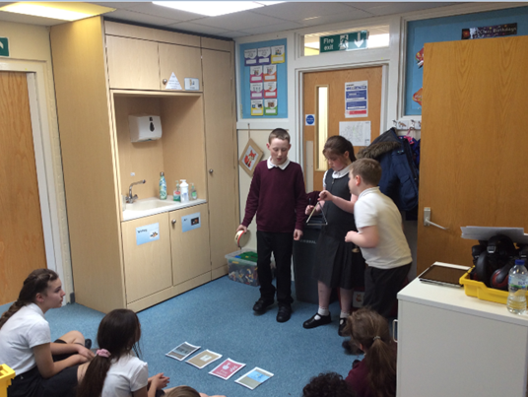
Strengths
- Robust curriculum that covers all the demands of the National Curriculum.
- Access to a wide range of professionally performed music via Musical Monday’s.
- Confident, enthusiastic teachers who adapt the curriculum to meet the needs of their pupils.
Ways forward
- Whole Staff CPD by a music professional to improve confidence in teaching composition and the use of technical terms.
- Record musical performances by the children in addition to taking photos to create bank of evidence of progression through school.
- Implement use of a Music Spine to harness children’s interest and increase their exposure to music through the ages.

Targets 2021-2022
- Create Music Evidence Folders on the bank-September 2021
Teachers to make a video recording of final performances after a unit of music work in the Dimensions Curriculum, to enrich evidence beyond photographs.
- Boomwhakers- September 2021
Investigate and purchase sets of Boomwhakers to provide an alternative to chime bars as a simple to access tuned instruments.
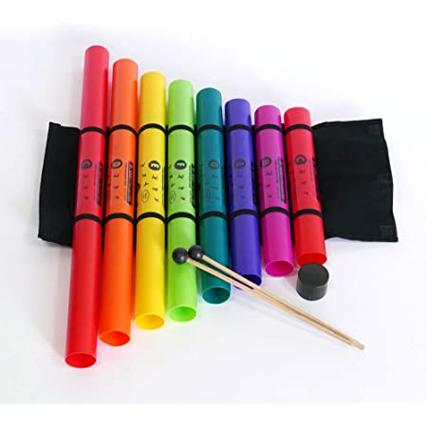
- Whole Staff CDP -TBC (Spring 2022)
Develop staff confidence and expertise delivering music lessons using Technical Terms and composing.
- Create a Music Spine-Spring 2022
Create a Music Spine using music suggested in the Model Music curriculum (March 2021) to ensure children are accessing music through time as well as the music from a wide range of cultures in the Dimensions Curriculum.
- Continue implementing ideas from the Model Music Curriculum to enhance our Music Curriculum- all year.
- To focus staff and pupil surveys and book scrutiny on the four primary stands from Model Music Curriculum- Spring 2022
- Singing
- Listening
- Composing
- Performing/Instrumental Performance

