2nd November 2022
Dear Parent and Carers

A new half term and we start by thanking our previous head boy and girl, Leon and Chloe for being fantastic role models and welcome our new head boys, Mason and Caleb, to the role. We aim to give as many of our Year 6 pupils the opportunity of being a leader as possible, as it promotes confidence, independence and self esteem.

Mental Health Champions
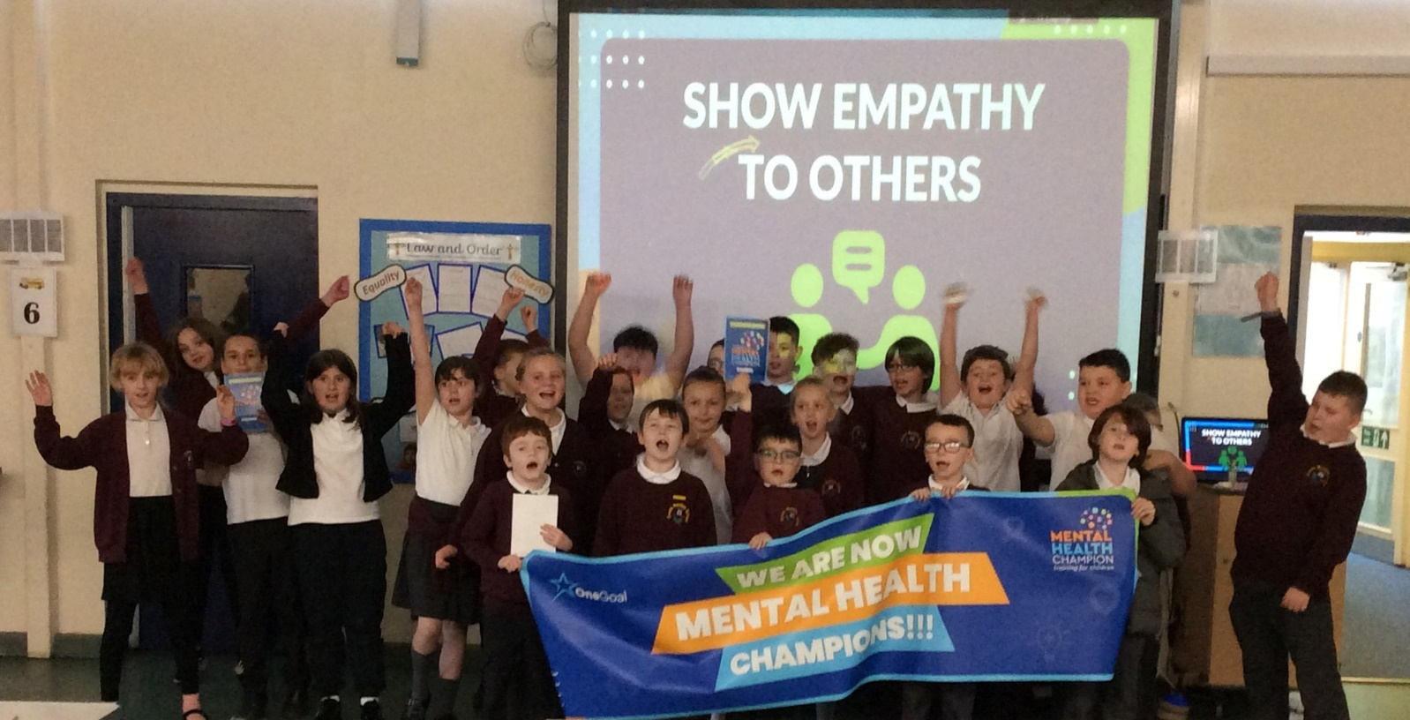
This week some of our classes took part in the mental health champion workshop. They learnt about positive mental health, relaxation techniques, how to cope with worry, how to support pupils struggling on the playground and how to promote being mentally healthy to others. Each child graduated at the end as a mental health champion! Photos are on facebook. It was a brilliant morning and supports our aim of being a positive mental health school.

Absence
Please remember to phone school before 9am each morning your child is absent. Please do not assume that by telling the escort we will receive the message. Michelle will call any family we have not heard from by 9am. Latest Covid guidance says we no longer test for Covid and treat it like a cold, so if the child is not feeling well enough for school they do not attend.

PE Kits
Please ensure your child has their PE kit in school. Can all items please be named.
Children in Need
This year Children in Need is on Friday 18th November. Your child can come to school in non uniform and if possible dressed in something yellow or spotty. Donations are requested for Children in Need. Please pass all donations to the escort or if you drop off, pass them to Michelle.

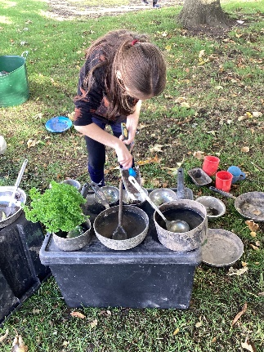
Forest Schools
Little Hobbits comes into school each Thursday afternoon to work with different classes for a 5 week block on Forest school skills. The children are able to come to school when it is their class’ turn in old clothes, to keep their uniform clean. Foxes and Tigers have two more weeks left. The children have learnt bushcraft skills, social and life skills and being taught how to complete tasks which bring some risk in a safe way. The children are loving Forest Schools!! Giraffes and Zebras start their 5 week block on the 24th November.
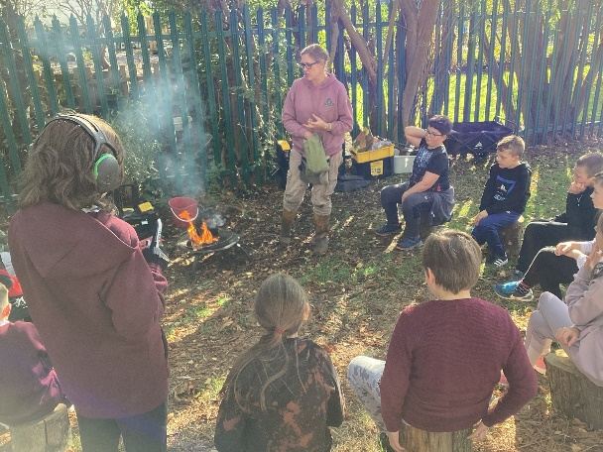
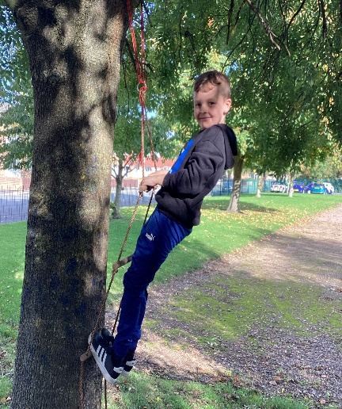
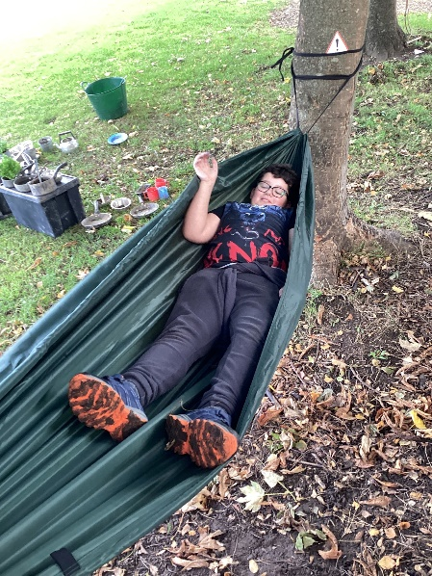

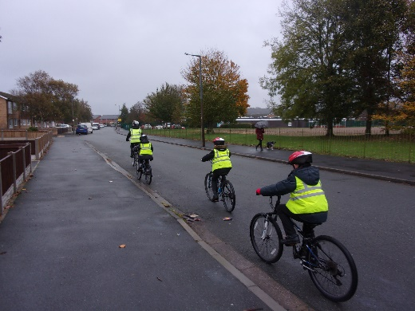
Bikeability
Year 6 pupils will take part in Bikeability next week. For some this will be learning to ride and for others this will be learning to ride on the road. Please make sure your child wears a warm coat next week. Being able to ride a bike safely is an important life skill, so if you can start practising this at a young age it will really help them.

School Photos
Individual photos will be taken on Tuesday 15th November and will go out to parents to purchase if they wish shortly after this date. Siblings will have photos taken together.

Coffee Morning
Our next coffee morning is on Frdiay 18th November 10-11am. Camhs are attending the session, so come along and seek advice and ask questions. Letters will go out nearer the time via Michelle.

November Dates for the Diary

3rd November – Forest schools – Foxes/Tigers week 3
8th November – Bikeability – learn to ride
9th November - Bikeability – learn to ride
10th November – Bikeabily – children able to ride learn road safety
11th November – Bikeability – children able to ride learn road safety
10th November - Forest schools – Foxes/Tigers week 4
11th November – Remembrance day – pupils will reflect together at 11am
15th November – Individual photos
17th November - Forest schools – Foxes/Tigers week 5 (last one)
- Judo 5 week block starts – Sharks and Owls
18th November – Children in Need Day – non uniform for a donation
- Whole school DT Day
- Camhs Parent coffee morning 10-11am
23rd November – Parent coffee morning with Michelle at 10am.

Please make sure you check your emails regularly as this is the way we send important information to you. Also, if you would like to see photos of your child taking part in all of the exciting enrichment activities we offer at school, then please follow us on Facebook.

Thanks for all your support.
If you have any questions about any of the above, please contact me.

Mrs Duncan

