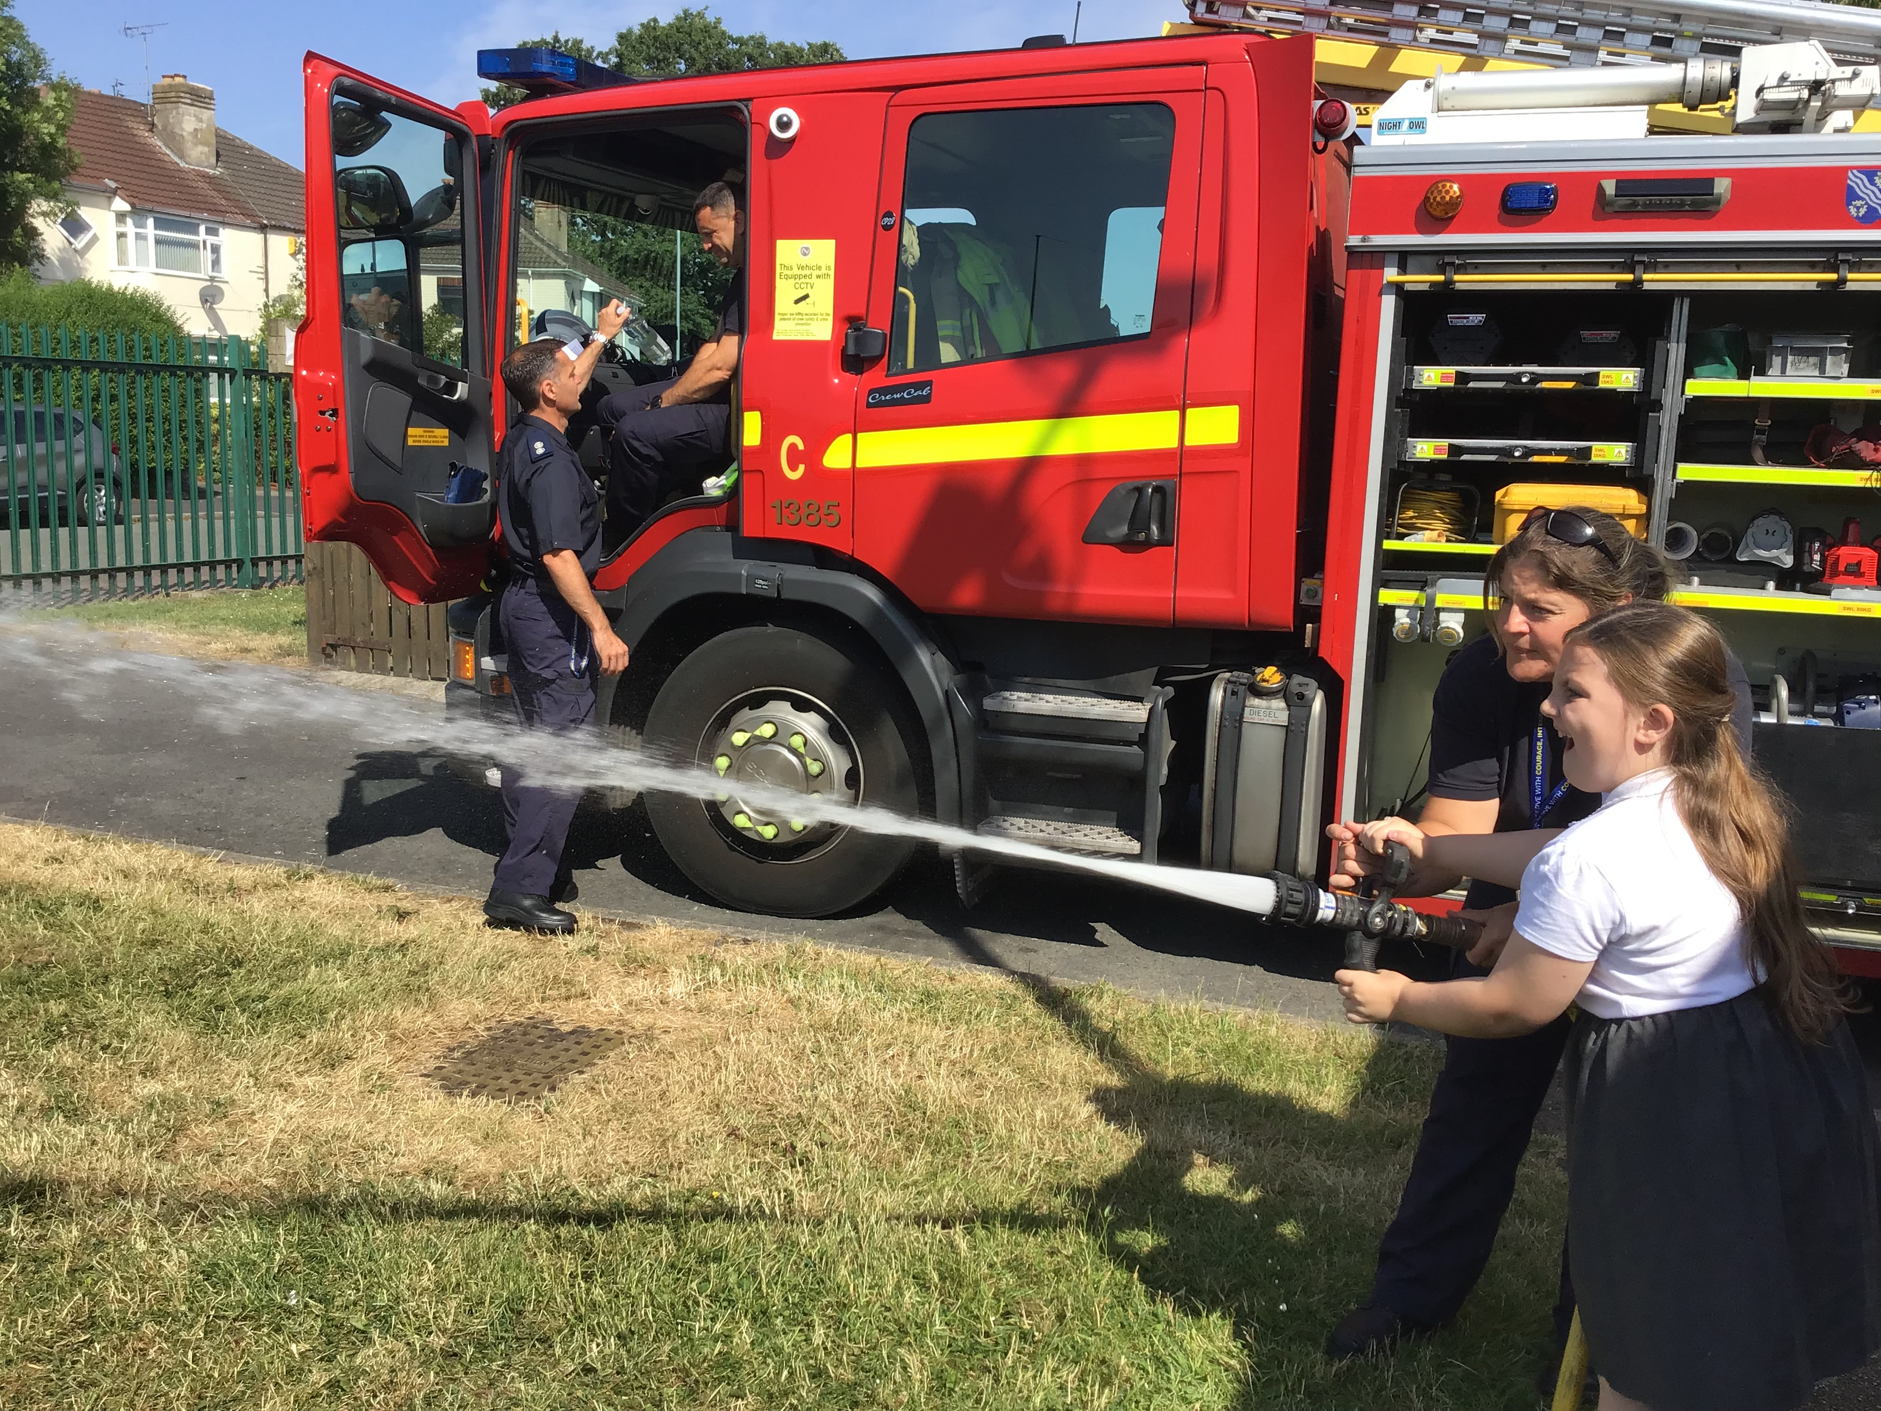
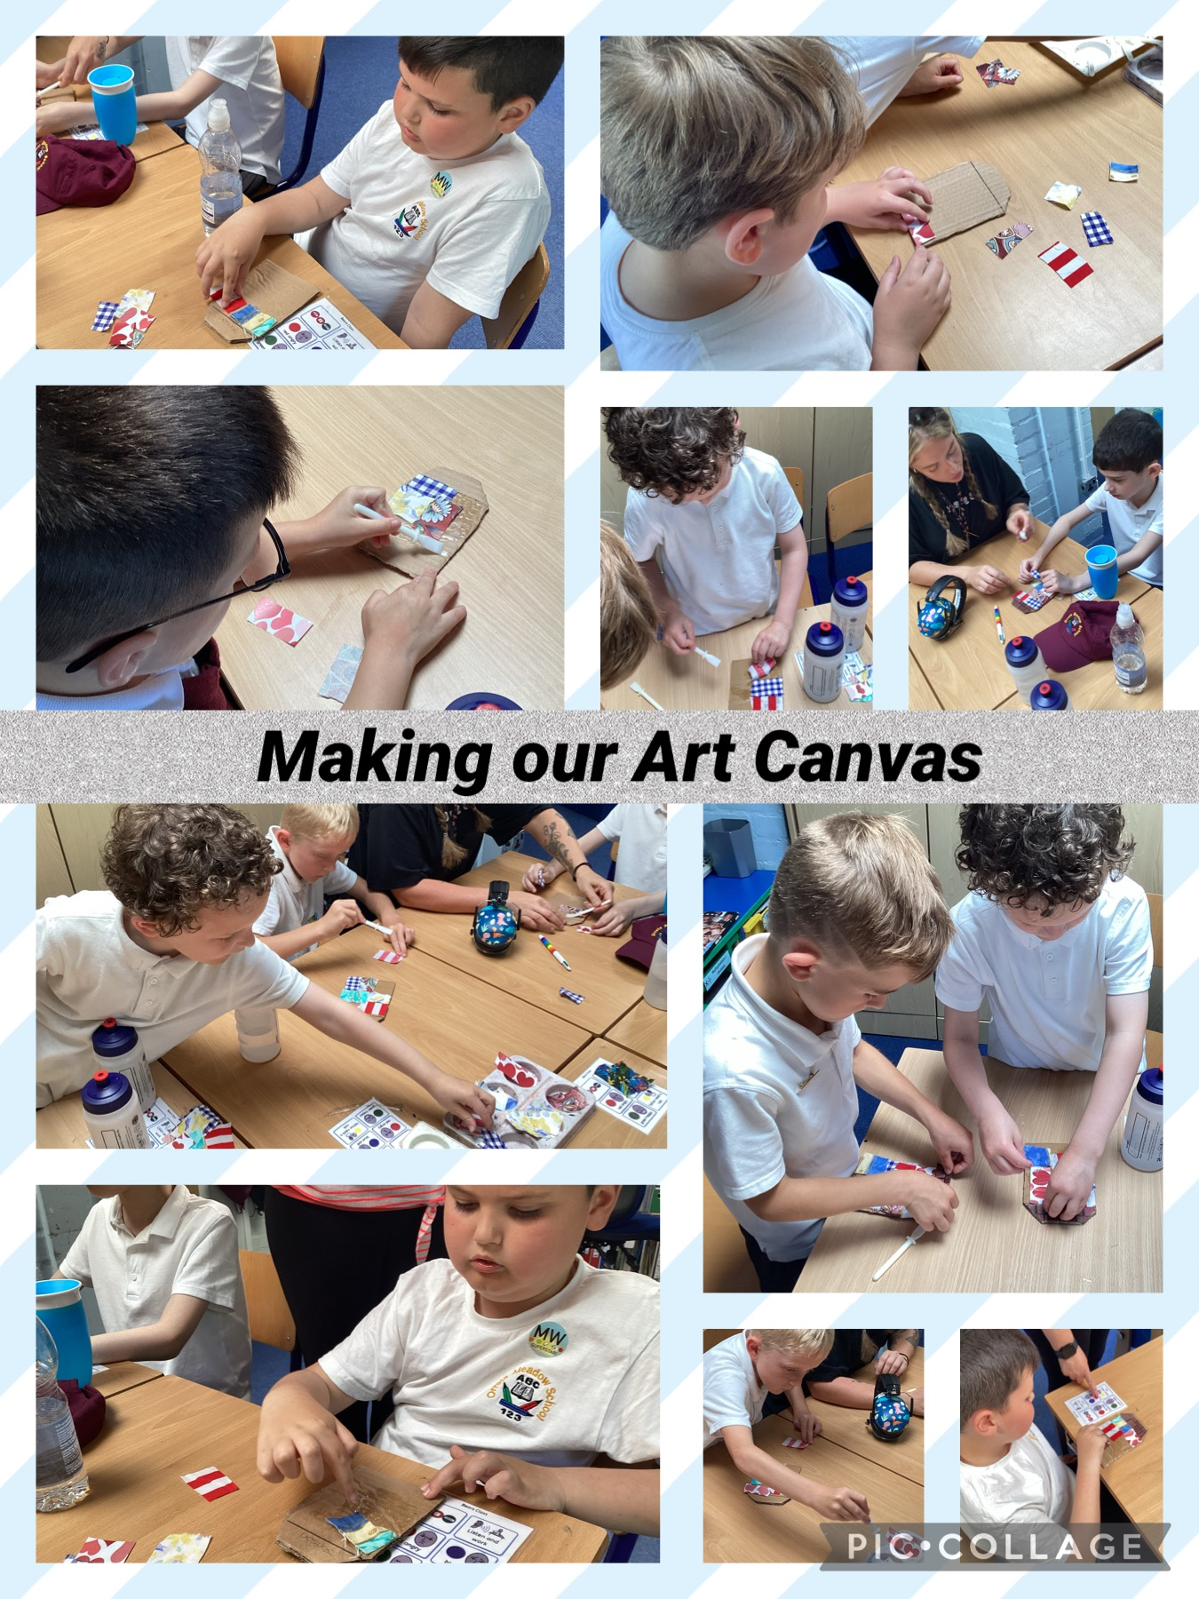

Governors Report – Summer 2023
PSHE
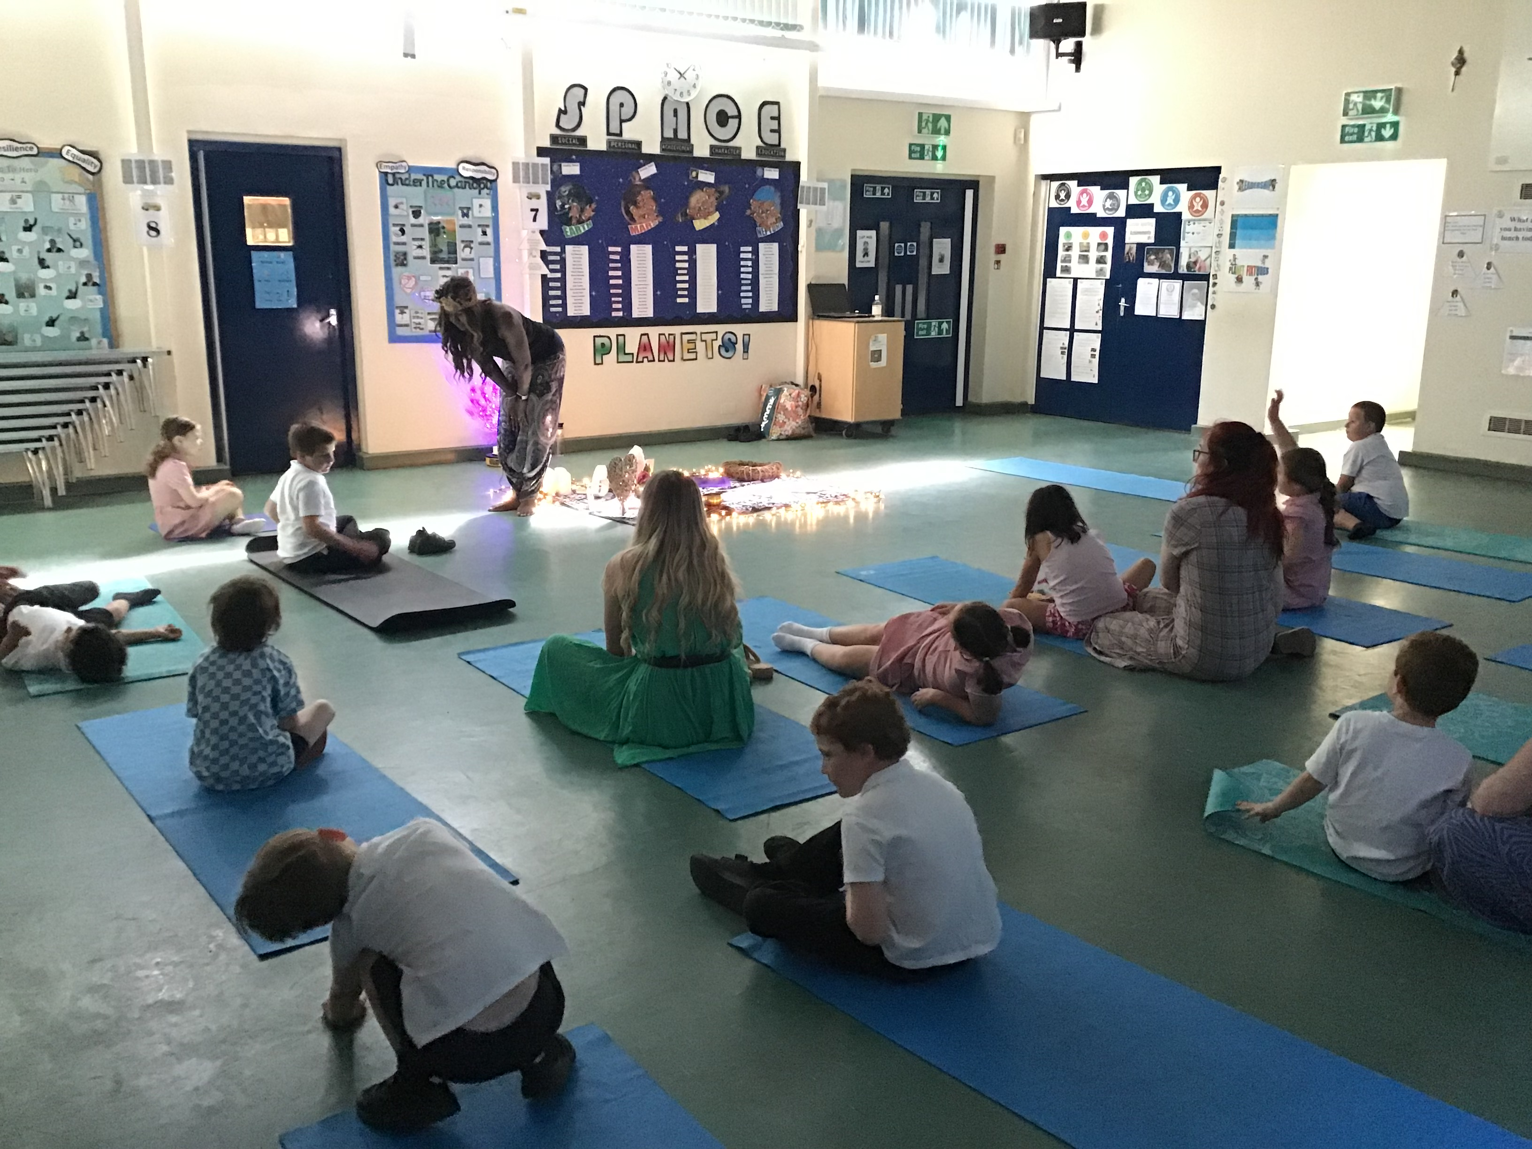
Roz Warren

Achievements
The ‘ways forward’ identified last year from this year’s school development plan and the actions taken:
To hold more independent sessions throughout the school year
This year we successfully held 3 Independence sessions to promote life skills including: laying a table, hanging out washing, ordering in a restaurant, paying for items in a shop, making a drink and snack etc the children thoroughly enjoyed these sessions and had the opportunity to practice these important life skills. It also supported the teachers in filling in certain targets from the Autism Tracker. Independence sessions will continue each term.
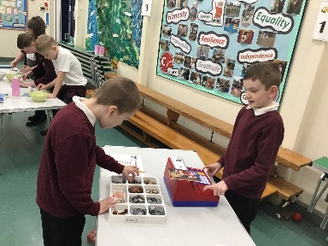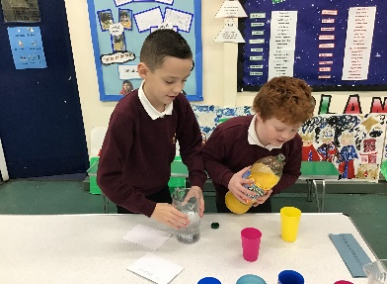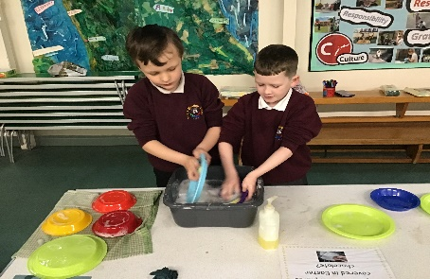
To support the lower cohort in developing emotions through researching resources and methods other schools use
I have signed up to a course for next year entitled ‘Emotion Detectives.’ Once I have completed the training resources will be purchased to facilitate this intervention in school to support the lower cohort in developing their emotions.
To look through the plans and see whether we can do more active outside sessions in PSHE
During Being Healthy and Safe week we completed several sessions outside to action this point from the pupil survey last year. It was also discussed at a staff meeting that when appropriate PSHE to carry out PSHE outside.
Zones of Regulation
Zones of Regulation has been implemented across the whole school this year. All classes have an interactive display board used to show which zone children are in. Children are asked at least twice a day (during register) how they feel. If they don’t fall into the green zone they have options to support their regulation. The staff and children’s language has changed to support this and we are finding that children can express their feelings and self-regulate or are supported to regulate better.

Another successful ‘Being Healthy and Safe’ week took place
We had another extremely successful ‘Being Healthy and Safe’ Week this year. We had a range of visitors including; Claremount Wake Up and Shake Up, MW Multi-Sports specialising in Rugby, Yoga, Kim – dental nurse, the Fire Brigade, the Life Boat, the Police, Mindfulness sessions. During this week there was several class trips including: the beach, Port Sunlight, Williamson Art Gallery and the Philharmonic Hall for a music event to give the children a sense of Awe and Wonder and to support Capital Culture. Internally we did the magic mile, art sessions, smoothie making (healthy eating), pet corner, litter picking in our local area, circuit training and independence sessions. We also organised a transitional afternoon for our Year 6’s at Claremount where they accessed sport sessions and met the Year 7 staff. The week is evidenced by photographs (which can be accessed on Facebook) It also is a well-being week for staff giving them a week off marking and a staff meeting of yoga.

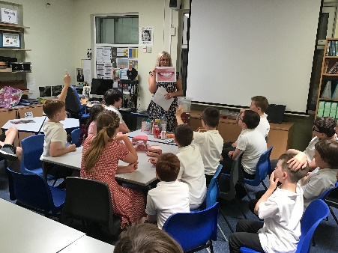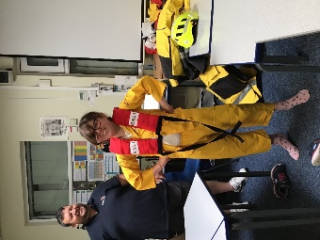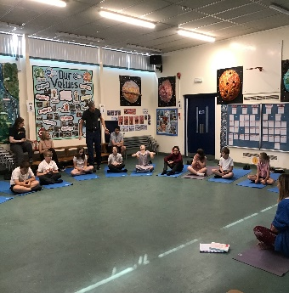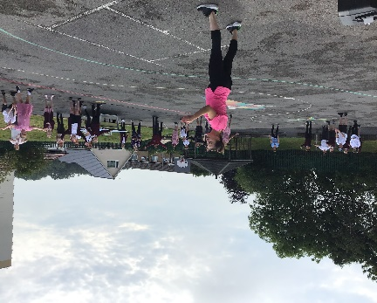
Autism Accreditation
After achieving the Advanced Status in our Autism Accreditation last year we continue to strive to make our school as Autistic friendly as possible. After advise from Altogether Trust this year we are changing backing paper to hessian to create less distraction, more inclusive calming and communication friendly school.

CPD
PSHE Lead
Throughout this academic year I have again taken part in the School Improvement Liverpool Primary PSHE subject leader meetings each term. These have continued to be extremely informative and ensures that we keep up to date with local and national developments in PSHE. Gaby Crolla from Claremount came in as a supportive mentoring role to ask questions on PSHE and advice on any further developments within the subject.
As part of my ongoing efforts to provide support and offer CPD to staff at Orrets Meadow I led a staff meeting on the Zones of Regulation in September. This supported the staff to deliver the Zones of Regulation programme to the children and for Zones of Regulation to be consistently rolled out to the whole school.
Quality of teaching and learning
I have completed a range of activities to oversee the teaching and learning of PSHE this academic year. I have collated and analysed the ASD Framework Data, Scrutinised the PSHE books against the planning, been on a learning walk and conducted staff and pupil voice surveys on RSE, Dimensions, and the Year 6 children and teachers on the Sex and Health Education lessons taught.
ASD Framework
The ASD Framework continues to give us supportive data on the children’s social communication, social interaction, social imagination and flexibility, sensory processing, emotional understanding and awareness, learnig and independence and participation. All new children were baselined during the autumn term and existing children’s ASD Frameworks have been updated accordingly. The IEP (Individual Education Plan) continue to reflect this and therefore gives future targets for children in the highlighted areas of need. The whole school area of strength this year came out a social interaction and the area for development came out as Independence and community. We will continue to promote independent skills through the curriculum and through the targeted independence sessions.

PSHE Book Scrutiny
All classes have taught the required statutory RSE content to date. This is evidenced through photographs and children’s work. Each session is evidenced in the PSHE book. Teachers continue to display a range of multisensory learning opportunities to try and engage and create sticky knowledge opportunities. PSHE book scrutinises have taken place each term to moderate coverage and work evidenced.

Learning Walk
My learning walks demonstrated children engaging, participating and learning. All classrooms felt a safe and secure environment for discussion and viewpoints. I thoroughly enjoyed walking round. I witnessed a range of different teaching activities that the teachers had planned carefully to support the children’s knowledge building. There teachers modelled language to support the children to develop. Teachers used a multisensory approach to learning and I witnessed role play, drama, sorting tasks, poster making etc to help the children to retain information.

Pupil Voice
Out of the 76 pupil’s that were surveyed:
I enjoy PSHE lessons | 79% of pupil’s enjoy PSHE
I can tell my teacher some of the things I learn in PSHE (using book) | 88% of pupil’s could tell their teachers something they have learnt about in PSHE
My teacher teaches PSHE using lots of different activities | 97% of pupil’s feel that PSHE is taught through lots of different resources
The activities in PSHE are interesting and engaging | 89% of pupil’s find PSHE interesting and engaging.
I feel comfortable sharing my ideas, views and opinions in PSHE | 84% of pupils feel comfortable sharing their views

Staff Voice

Does the Dimensions curriculum support you to teach the children in PSHE? | 100% of teachers agreed that Dimensions supported the teaching of RSE.
Do you feel confident teaching the revised RSE content? | 100% of teachers feel confident teaching RSE.
Are the majority of RSE lessons easy and straight forward to deliver? | 100% of teachers agreed that the RSE lessons were easy and straight forward to deliver.
Is it easy to resource your PSHE sessions? | 67% of teachers agreed it was easy to resource PSHE.
Do the children demonstrate a positive attitude and engagement with the PSHE curriculum? | 100% of teachers say that children demonstrate a positive attitude and engagement with the PSHE curriculum.
Do you feel confident in teaching the different areas of PSHE? | 100% of teachers feel confident teaching the different areas.
Do you need any support in PSHE? | 100% of teachers do not require support

Year 6 staff Sex and Health Education Questionnaire
- Staff felt confident teaching Sex and Health Education.
- Staff felt Dimensions sessions were easy and straight forward to teach.
- Staff felt some lessons needed adapting but felt comfortable doing this.
- Staff felt Lesson 2 needed adapting or leaving out.
- Staff felt children were positive, thankful for learning, asked lots of questions and seemed to learn a lot.

Year 6 pupil Sex and Health Education Questionnaire (done as a class)
- Children understand what a healthy relationship is.
- Children understand what an unhealthy relationship is.
- Children understand what a sexual relationship is.
- Children understood more about body change.
- Children seemed confident and happy to discuss topics.

Strengths
- Zones of Regulation
- Autism Tracker data
- Independence sessions
- Being Healthy and Safe Week
- Visitors coming in to promote living in the wider world, health and well -being and relationships.
- The enthusiasm for teaching PSHE and the children’s response
- Autism Accreditation Advanced status

Ways forward - Targets
- To train to be an Emotions Detective and run interventions. Autumn 1
- To continue to hold independent sessions throughout the school year. Each term
- To look at the resources for PSHE sessions (from the survey 33% of staff found it difficult to resource certain lessons) Autumn 1
- To source some PSHE games (from the survey several children would like more games) Autumn 1
- To rewrite lesson 2 of the Year 6 sex education to make it more appropriate for our cohort. Spring 1

